Monthly Quality Update
July 2022

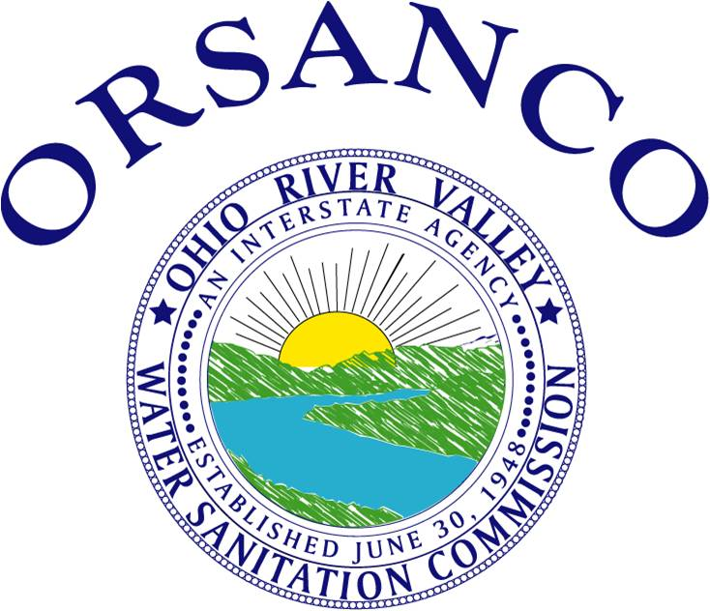

OHIO RIVER VALLEY
WATER SANITATION COMMISSION
5735 Kellogg Avenue, Cincinnati, Ohio 45230 (513) 231-7719 Fax (513) 231-7761

Flows

Average flows at seven Ohio River locations are displayed below. At each location the July 2022 average flow (red bar) is contrasted with the long-term average monthly flow (blue bar).

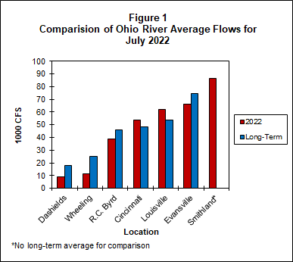

Bacteria

The bacteria monitoring results from five of the six Ohio River locations in July are in the attached graphs. ORSANCO’s water quality criteria for the protection of human health during the contact recreation season are:

• E. coli count is not to exceed 240 CFU/100mL in more than 25 percent of samples. (E.coli is shown with a red line on the graph.)
• E. coli shall not exceed 130 CFU/100mL as a 90-day geometric mean, based on not less than five samples per month.

ORSANCO’s water quality criteria for the protection of public water supply year round are:

• Fecal Coliform shall not exceed 2,000/100mL as a monthly geometric mean based on not less than five samples per month.

Pittsburgh
In Pittsburgh, ORM 1.4M and ORM 4.3M both had one individual exceedance for E.coli for July.

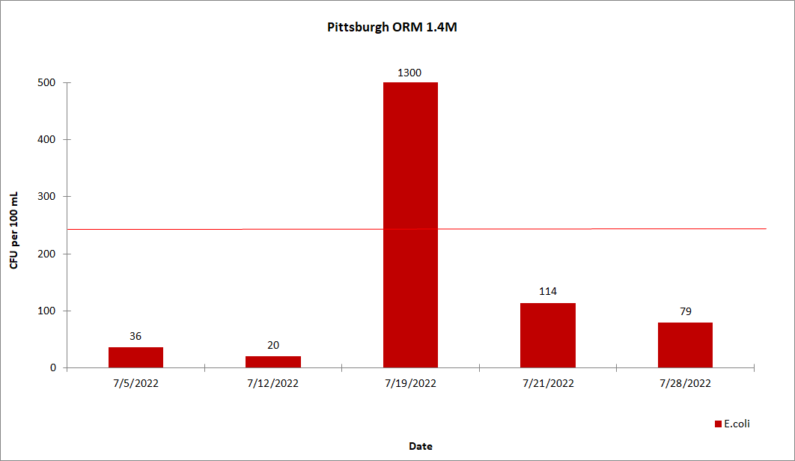

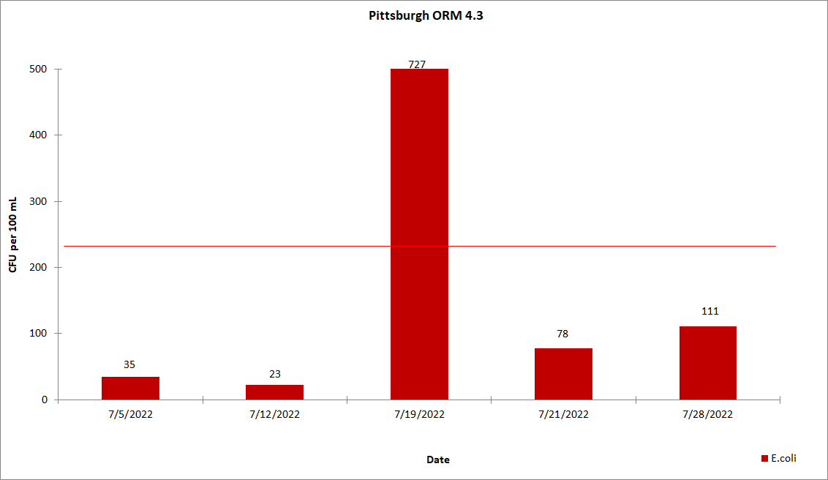

Wheeling
In Wheeling, ORM 86.8 did not exceed the E.coli criteria for the month of July. ORM 92.8 had two individual exceedances for E.coli for the month of July.

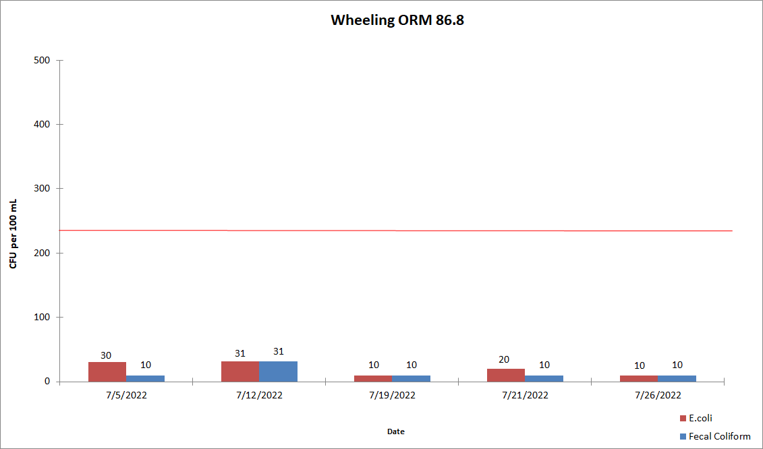

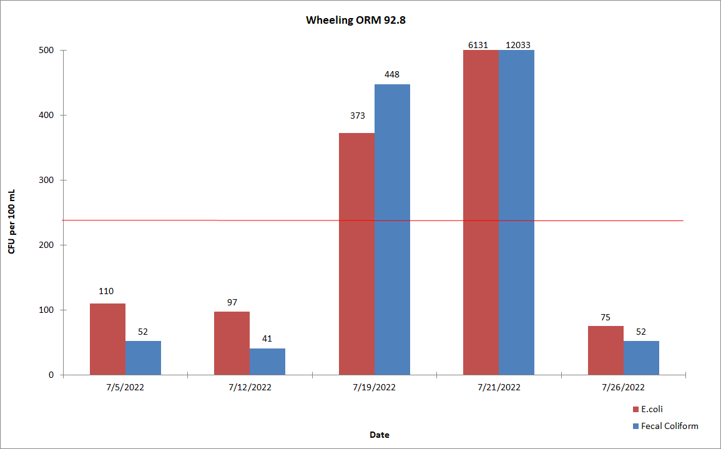
Huntington
In Huntington, ORM 305.1 and ORM 314.8 had one individual exceedance for E.coli for the month of July.

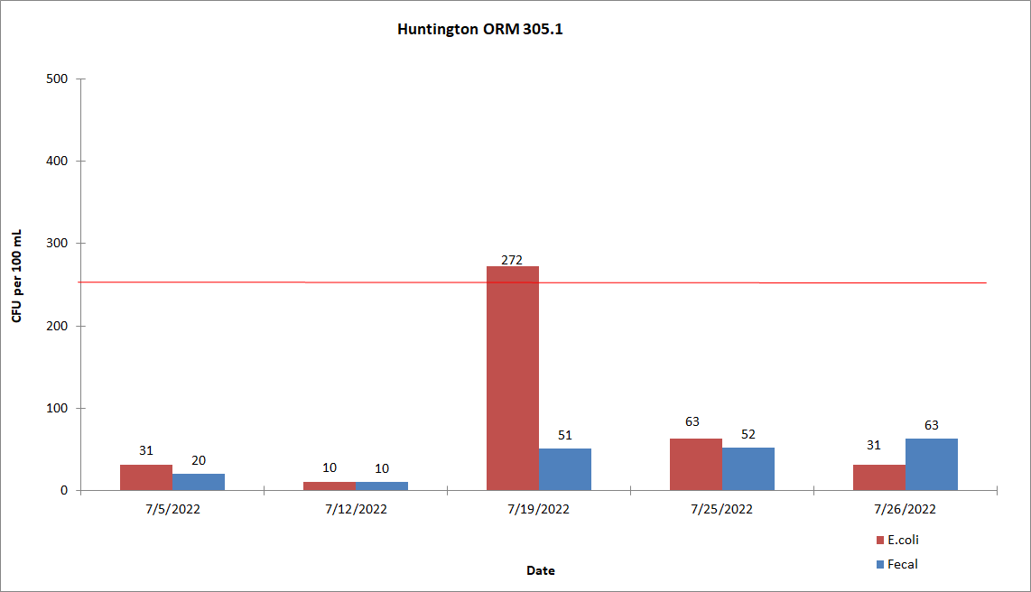

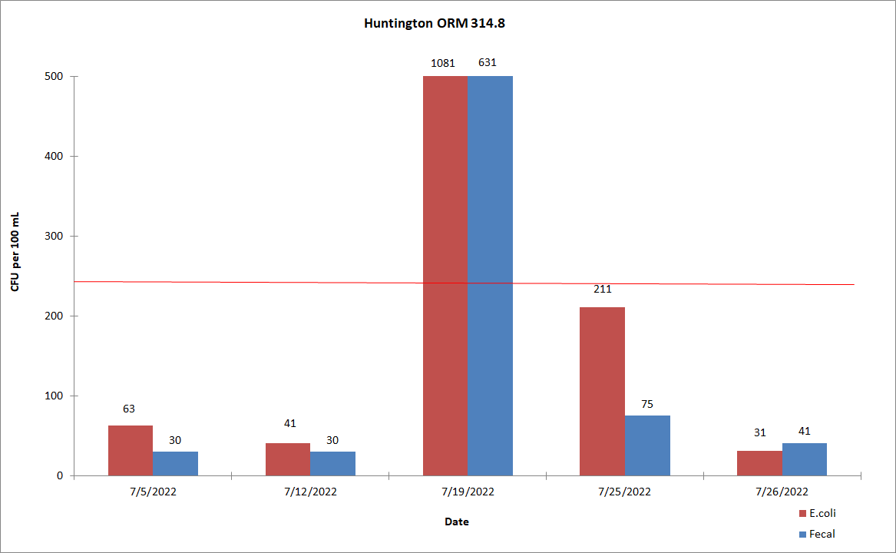

Cincinnati
In Cincinnati, ORM 462.6, ORM 470.0 and ORM 477.5 did not exceed the E.coli criteria for the month of July. 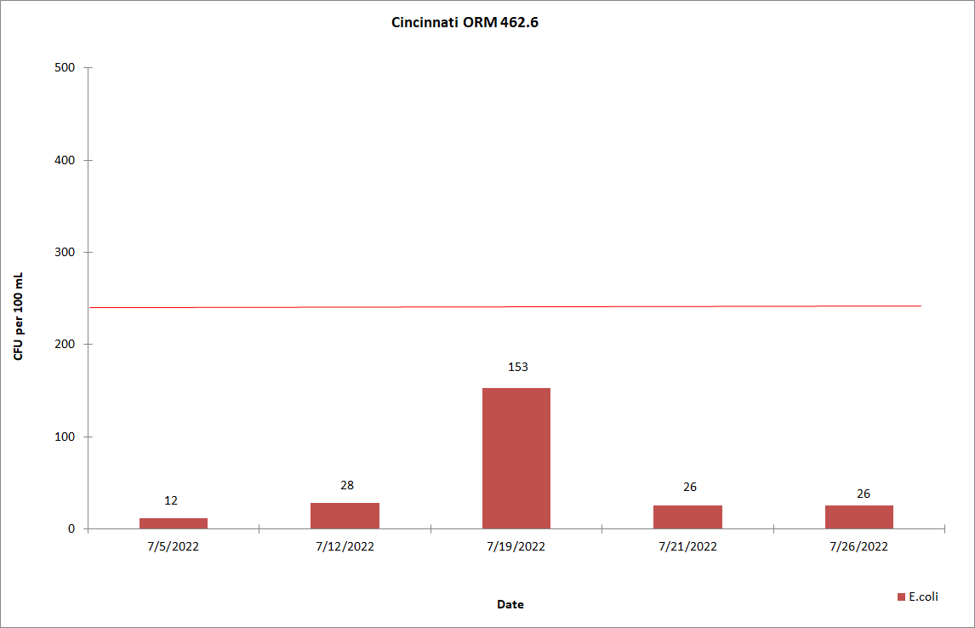

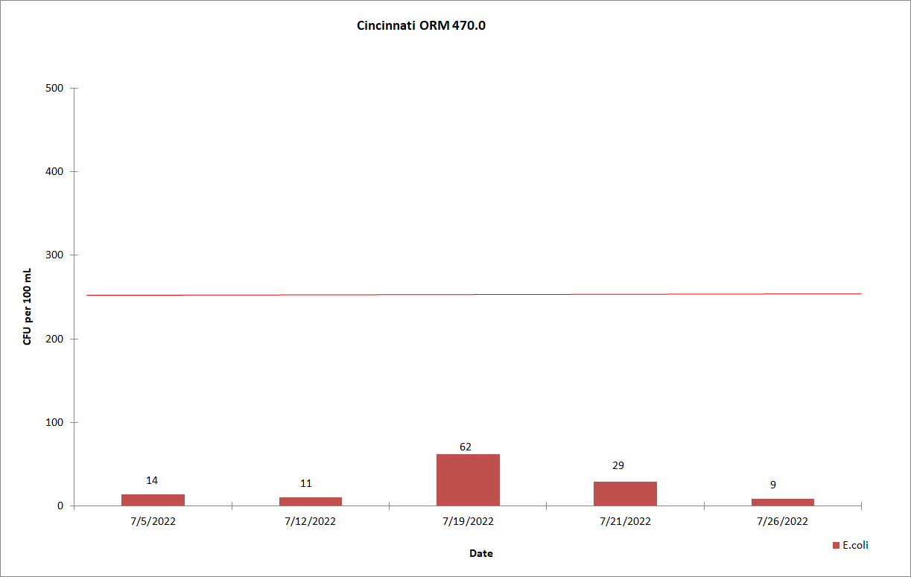

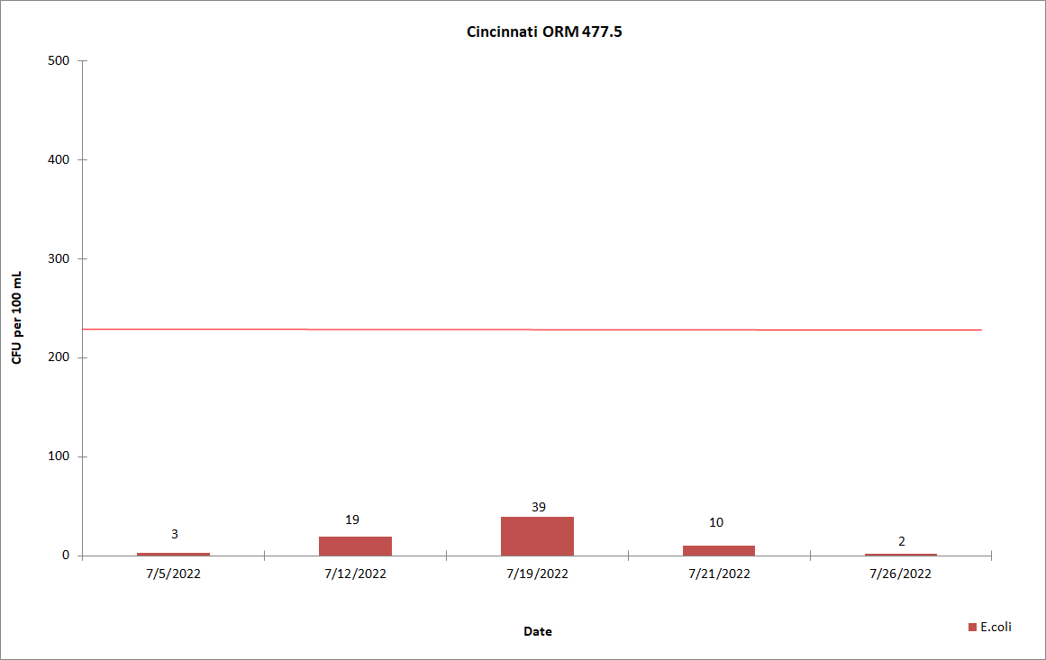

Louisville
In Louisville, ORM 594.0 had one individual exceedance for E.coli. ORM 619.3 had two individual exceedances for E.coli for the month of July.
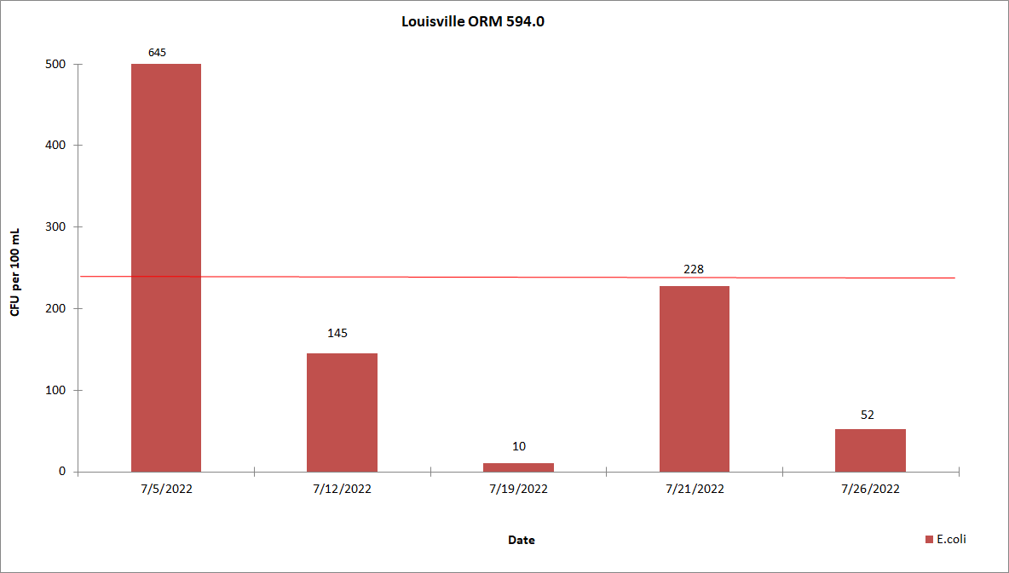

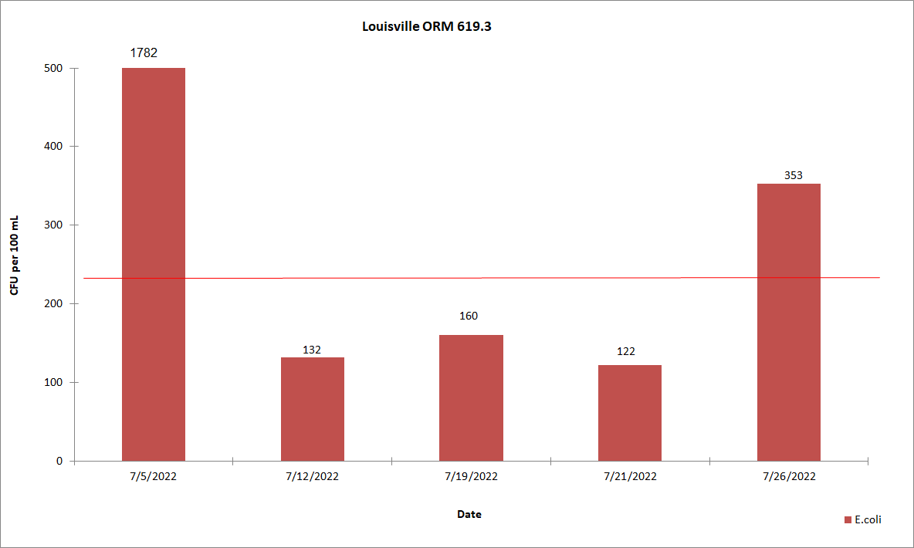

Evansville
In Evansville, ORM 791.5 and ORM 793.7 had one individual exceedance for E.coli for the month of July.

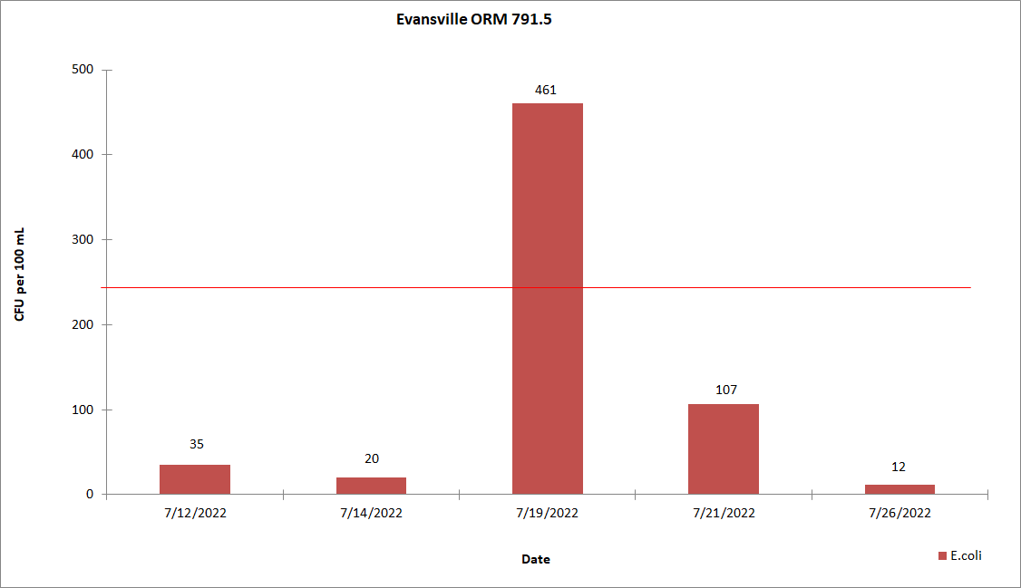

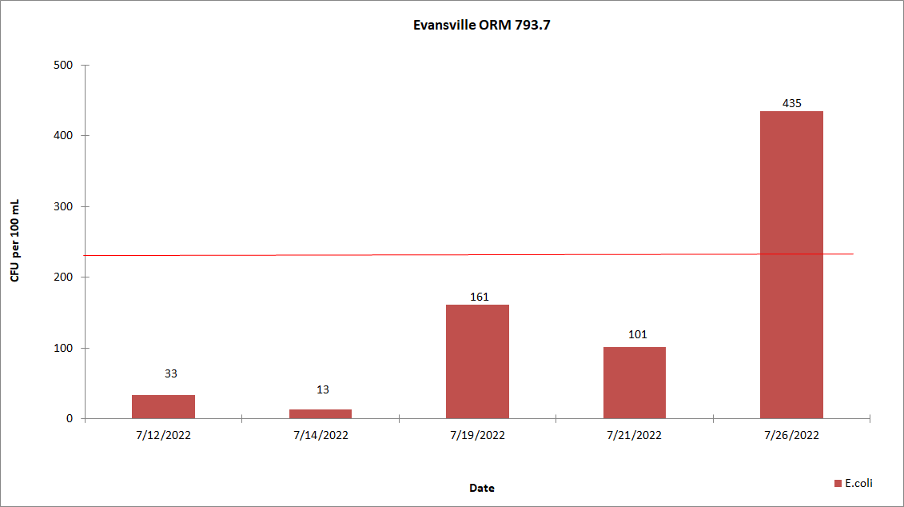

Dissolved Oxygen and Temperature

A summary of the dissolved oxygen and temperature readings collected in June 2022 are displayed in the attached tables. During the months of May through October, ORSANCO interrogates eleven stations for dissolved oxygen (D.O.) and temperature data once per day, Monday through Friday, for the previous 24-hour period. This data is compiled in-house to produce a report showing the minimum, maximum and average of the acquired D.O. and temperature readings. ORSANCO’s water quality criteria for the protection of warm water aquatic life habitat are:

- The minimum D.O. concentration shall not be less than 4.0 mg/L at any time.
- Average D.O. concentration shall be at least 5.0 mg/L for each calendar day.
- During the April 15 – June 15 spawning season, a minimum D.O. concentration of 5.0 mg/L shall be maintained at all times.
- The monthly average of the daily maximum for July 1-31 is:

  - 89.0 °F at MP 0 to MP 341.
  - 89.0 °F at MP 341.1 to MP 606.8.
89.0 °F at MP 606.9 to MP 981.

Markland saw D.O. levels drop below the average of 5.0 mg/L. There were no temperature violations for the month of July.

Please click on the link below to be directed to the DO/Temperature tables for July 2022:
http://www.orsanco.org/dissolved-oxygen-and-temperature

Atrazine

Evansville drinking water utility samples the Ohio River at their intake and analyzes for atrazine by immunoassay technique. Results for July 2022 are presented below. Evansville had no criteria violations of the Maximum Contaminant Level (MCL) of 3.0 ug/L set by the Safe Drinking Water Act for finished drinking water.

