Monthly Quality Update
May 2017
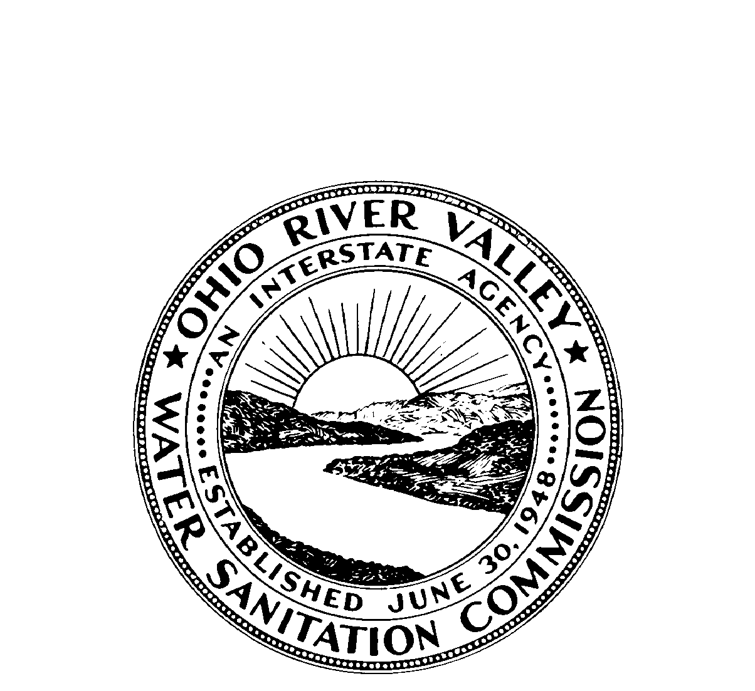

OHIO RIVER VALLEY
WATER SANITATION COMMISSION
5735 Kellogg Avenue, Cincinnati, Ohio 45230 (513) 231-7719 Fax (513) 231-7761

Flows

Average flows at seven Ohio River locations are displayed below. At each location the May 2017 average flow (black bar) is contrasted with the long-term average monthly flow (gray bar). At all locations the May 2017 average flow was above the long-term average monthly flow.

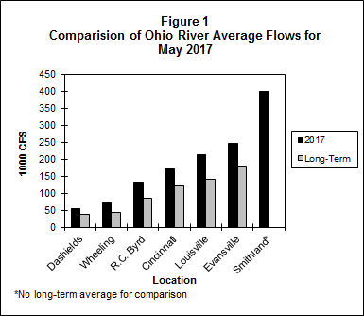

Bacteria

The bacteria monitoring results from six Ohio River locations in May 2017 are in the attached graphs. There are thirteen sites being sampled and West Virginia is the only state that has both Fecal Coliform and E.coli results. ORSANCO’s water quality criteria for the protection of human health during the contact recreation season are:

• E. coli count is not to exceed 240 CFU/100mL in more than 25 percent of samples. (E.coli is shown with a red line on the graph.)
• E. coli shall not exceed 130 CFU/100mL as a 90-day geometric mean, based on not less than five samples per month.

ORSANCO’s water quality criteria for the protection of public water supply year round are:

• Fecal Coliform shall not exceed 2,000/100mL as a monthly geometric mean based on not less than five samples per month.

Pittsburgh
In Pittsburgh, ORM 1.4M and ORM 4.3 had three individual exceedances for E.coli. Only four days were sampled due to boat issues.

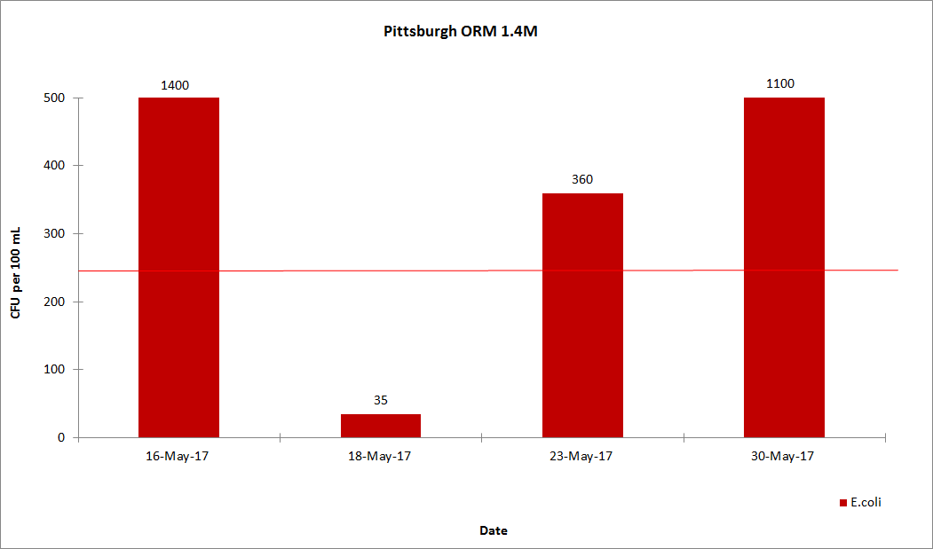

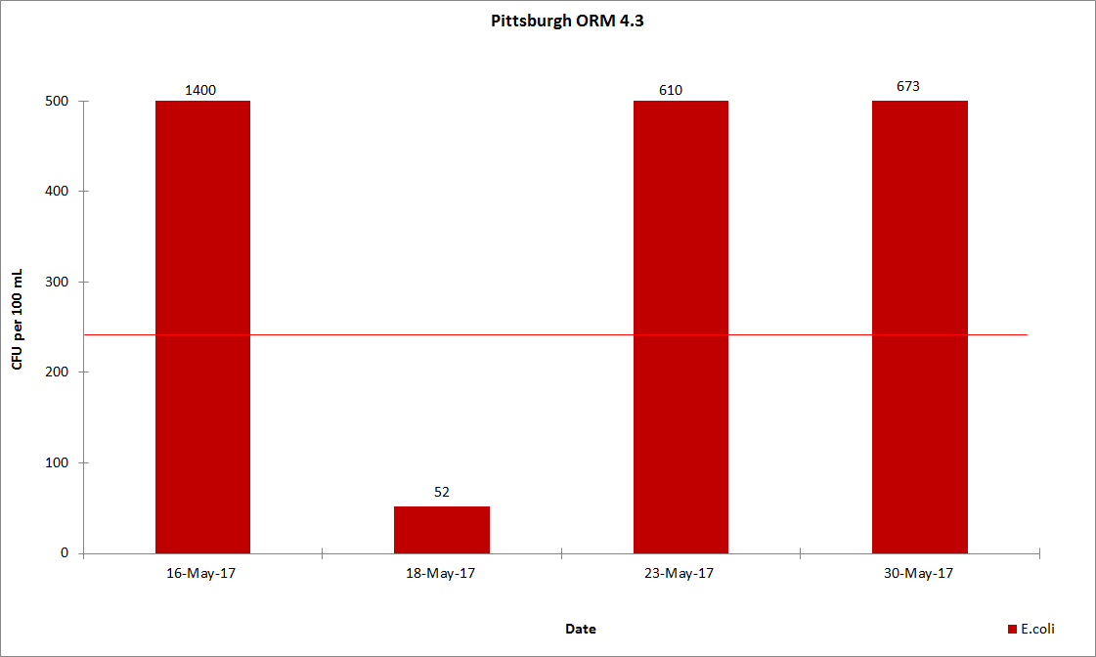

Wheeling
In Wheeling, ORM 86.8 and one individual exceedance for E.coli. ORM 92.8 had two individual exceedances for E.coli.

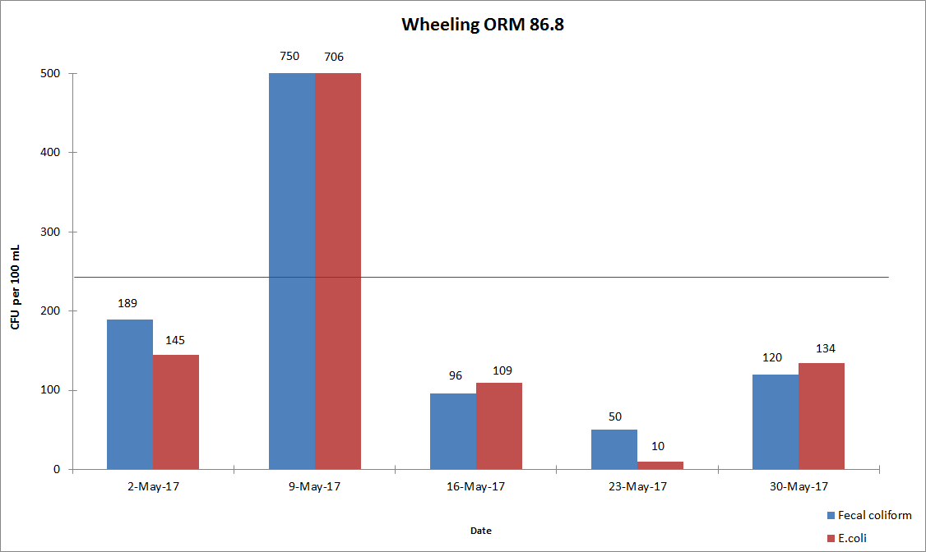

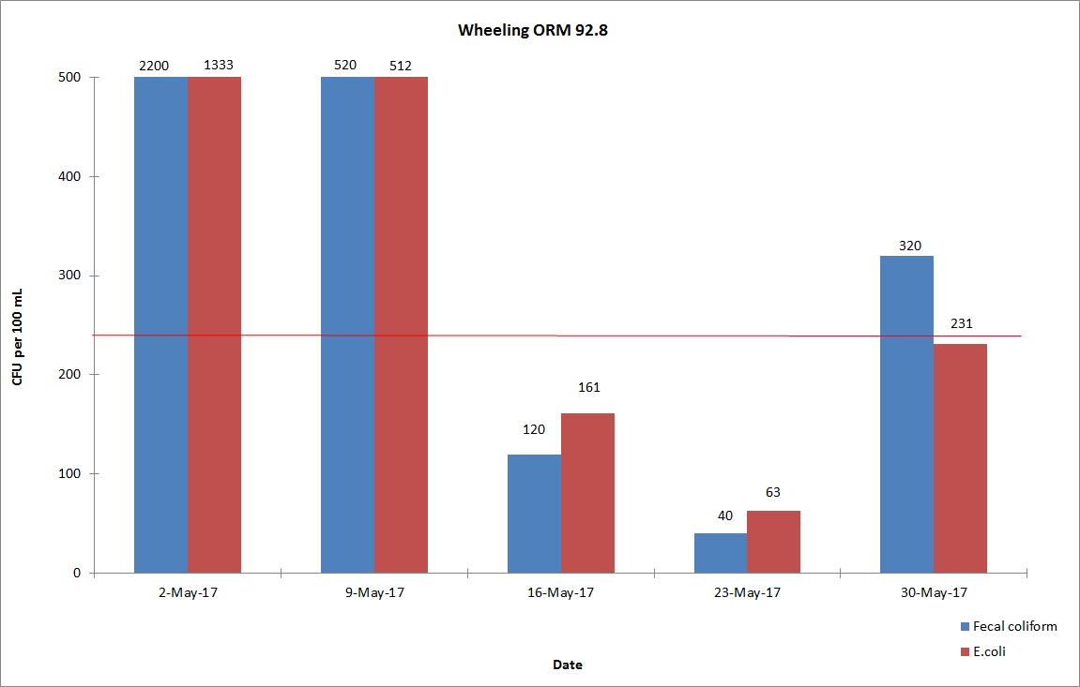Huntington
In Huntington, ORM 305.1 had two individual exceedances for E.coli. ORM 92.8 had one individual exceedance for E.coli.

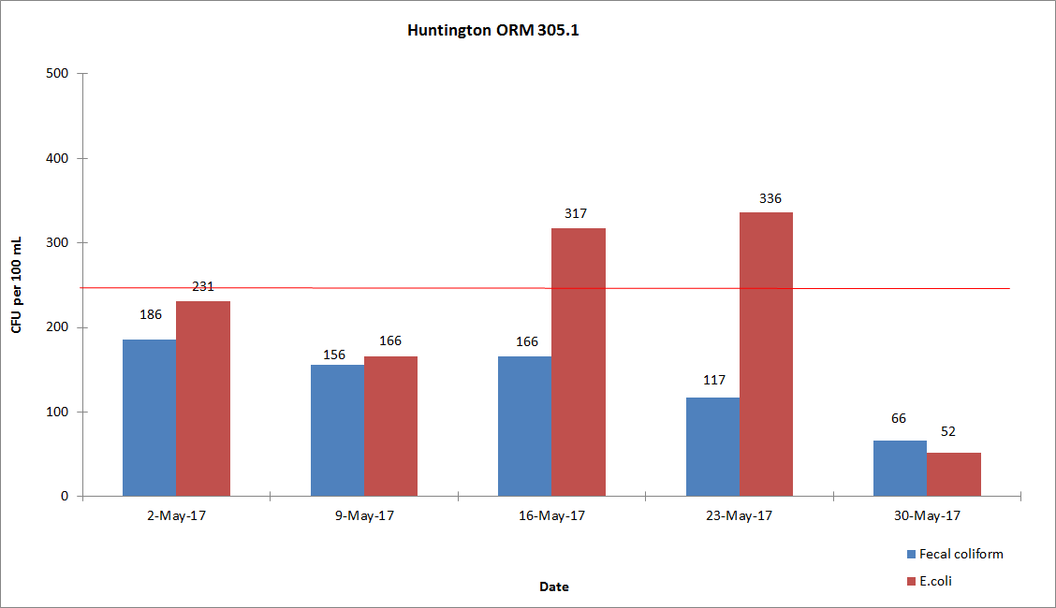

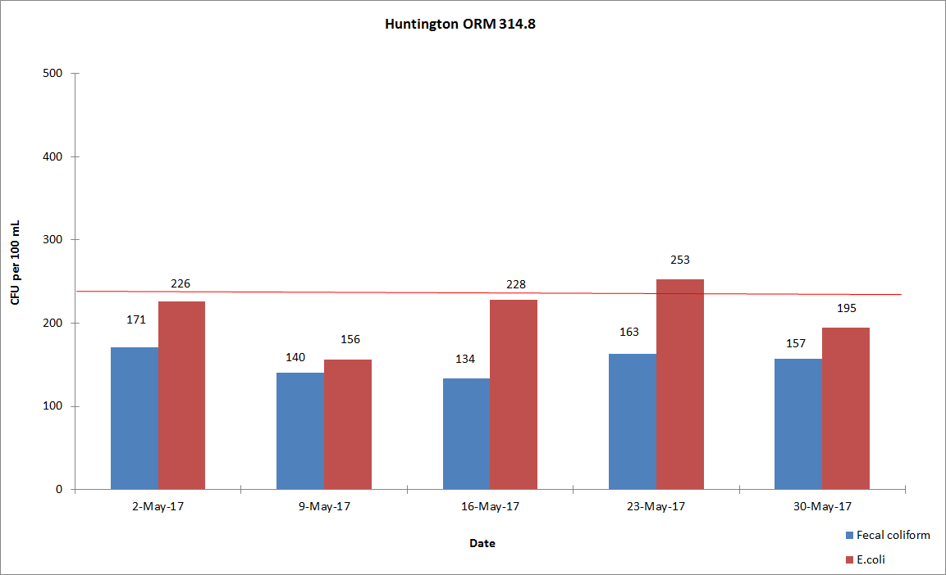Cincinnati
In Cincinnati, ORM 462.6 had three individual exceedances for E.coli. ORM 470.0 and ORM 477.5 had two individual exceedances for E.coli.

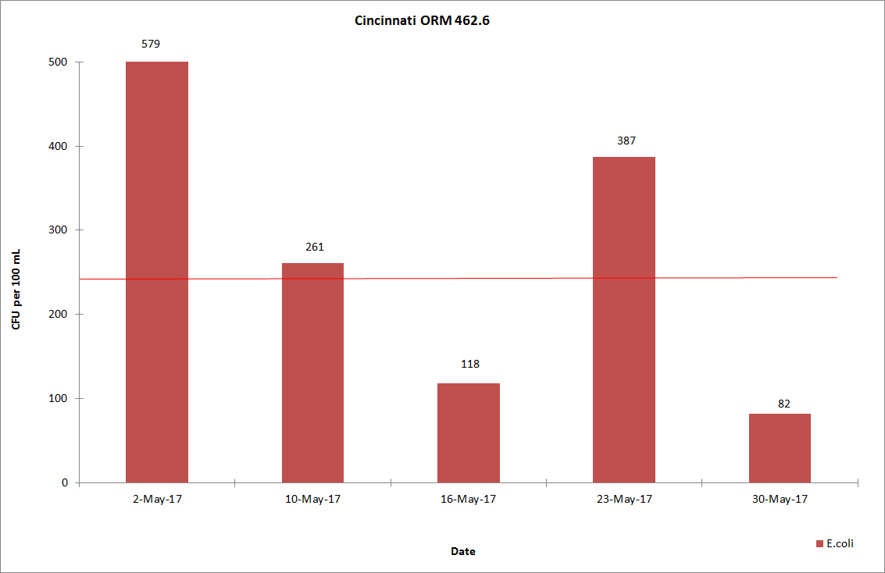

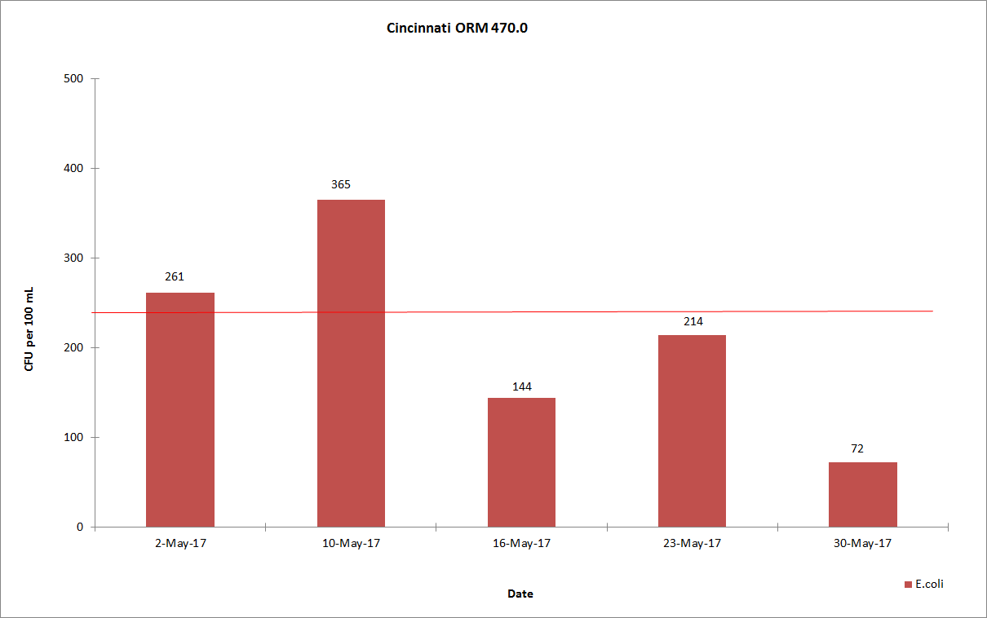

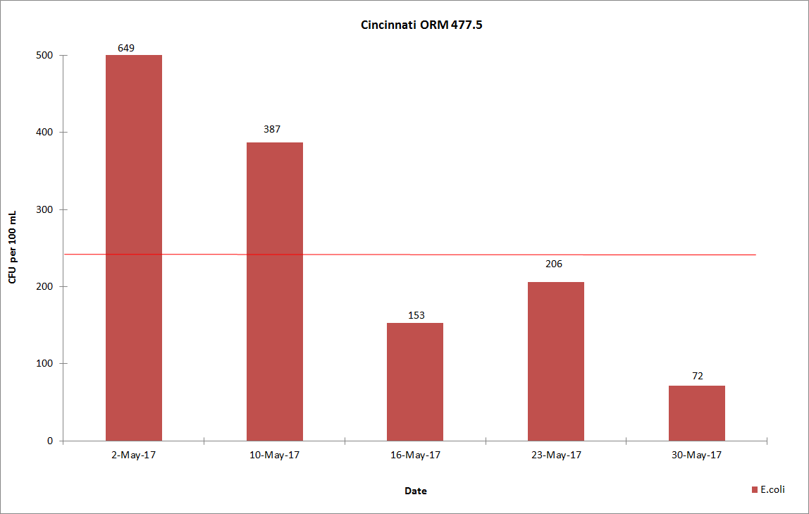

Louisville
In Louisville, ORM 594.0 had two individual exceedances for E.coli. ORM 619.3 had five individual exceedances for E.coli.
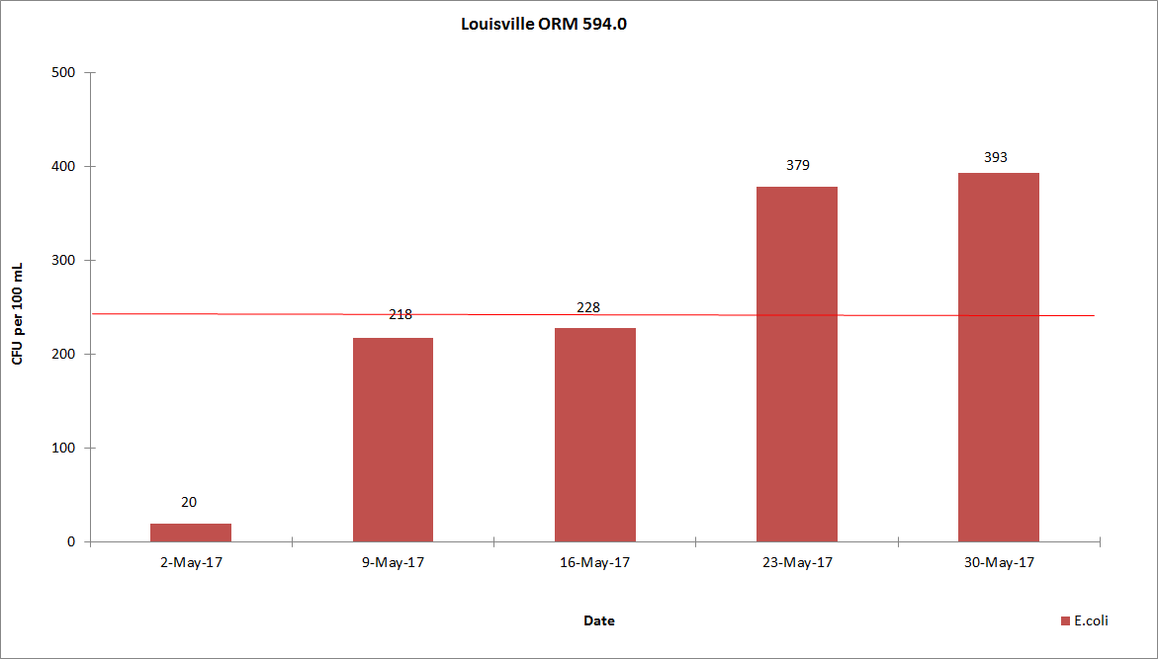

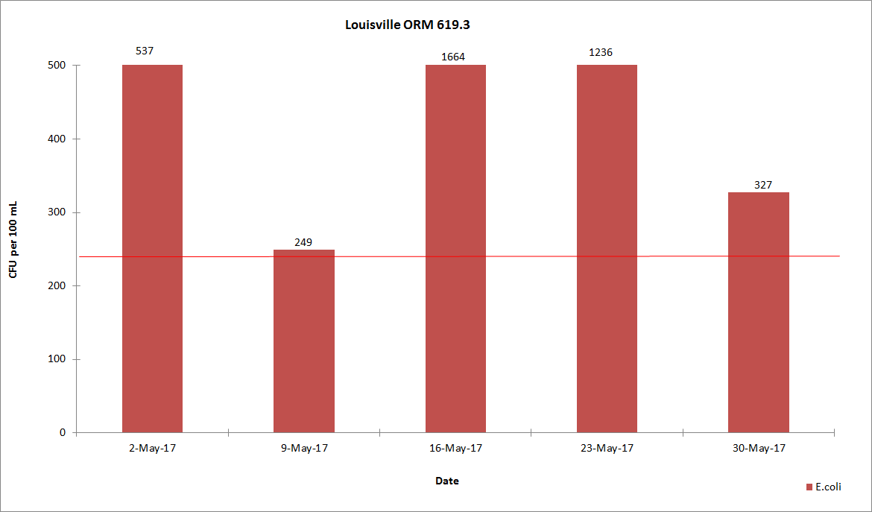

Evansville
In Evansville, ORM 791.5 had two individual exceedances for E.coli. ORM 793.7 had one individual exceedance for E.coli.

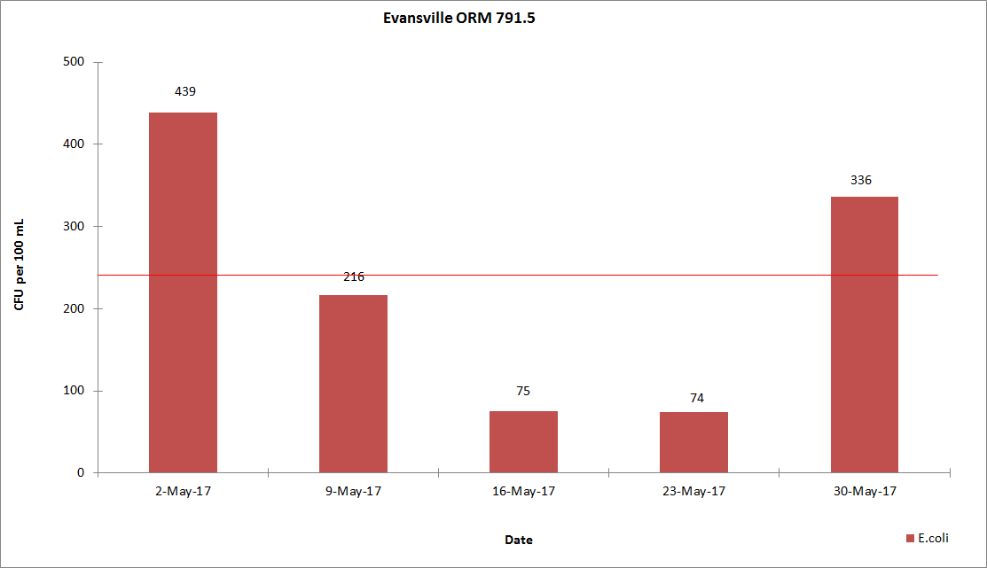

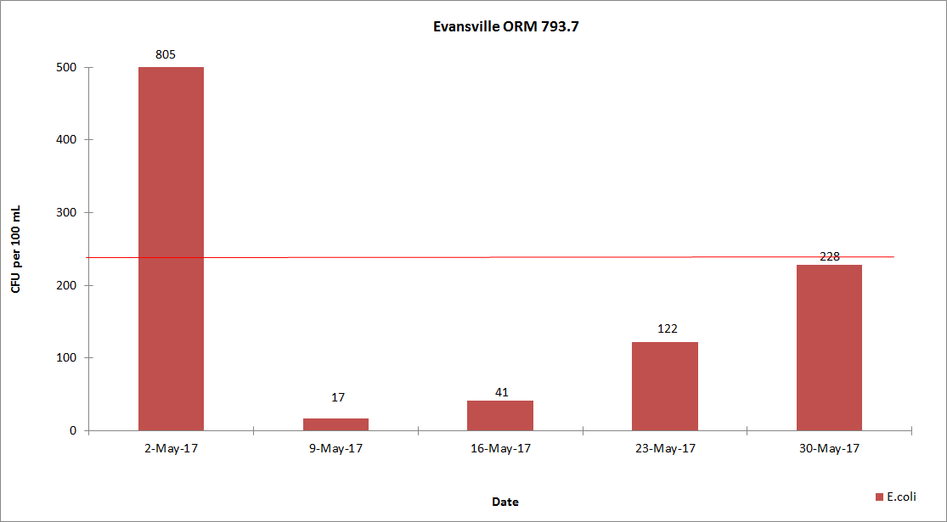

Dissolved Oxygen and Temperature

During the months of May through October, ORSANCO interrogates eleven stations for dissolved oxygen (D.O.) and temperature data once per day, Monday through Friday, for the previous 24-hour period. This data is compiled in-house to produce a report showing the minimum, maximum and average of the acquired D.O. and temperature readings. ORSANCO’s water quality criteria for the protection of warm water aquatic life habitat are:

- The minimum D.O. concentration shall not be less than 4.0 mg/L at any time.
- Average D.O. concentration shall be at least 5.0 mg/L for each calendar day.
- During the April 15 – June 15 spawning season, a minimum D.O. concentration of 5.0 mg/L shall be maintained at all times.
- The monthly average of the daily maximum for May is:

  - 71.2 °F at MP 0 to MP 341.
  - 76.4 °F at MP 341.1 to MP 606.8.
  - 71.4 °F at MP 606.9 to MP 981.

There were no DO or temperature exceedances for the month of May.

Please click on this link to be directed to the DO/Temperature tables for May 2017: http://www.orsanco.org/dissolved-oxygen-and-temperature
Atrazine

Evansville drinking water utility samples the Ohio River at their intake and analyzes for atrazine by immunoassay technique. Results for May 2017 are presented below. Evansville had one criteria violation of the Maximum Contaminant Level (MCL) of 3.0 ug/L set by the Safe Drinking Water Act for finished drinking water on May 12, 2017. The result was 3.01 ug/L.

