Monthly Quality Update
October 2016
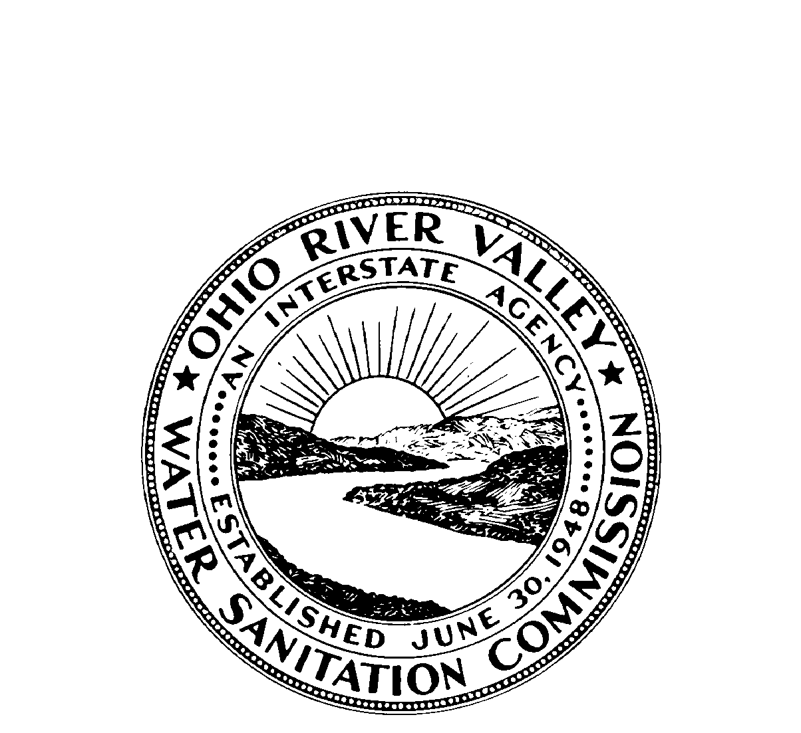

OHIO RIVER VALLEY
WATER SANITATION COMMISSION
5735 Kellogg Avenue, Cincinnati, Ohio 45230 (513) 231-7719 Fax (513) 231-7761

Flows

Average flows at seven Ohio River locations are displayed below. At each location the October 2016 average flow (black bar) is contrasted with the long-term average monthly flow (gray bar).

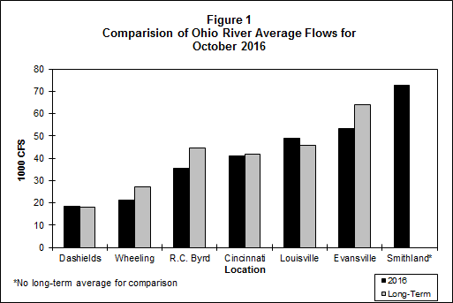

Bacteria

The bacteria monitoring results from six Ohio River locations in October 2016 are in the attached graphs. Beginning with the 2016 Contact Recreation season (April through October), there are thirteen sites being sampled. ORSANCO’s water quality criteria for the protection of human health during the contact recreation season are:

• E. coli count is not to exceed 240 CFU/100mL in more than 25 percent of samples. (E.coli is shown with a red line on the graph.)
• E. coli shall not exceed 130 CFU/100mL as a 90-day geometric mean, based on not less than five samples per month.

ORSANCO’s water quality criteria for the protection of public water supply year round are:

• Fecal Coliform shall not exceed 2,000/100mL as a monthly geometric mean based on not less than five samples per month.

Pittsburgh
In Pittsburgh, ORM 1.4M had two individual exceedances for E.coli. ORM 4.3 had three individual exceedances for E.coli.

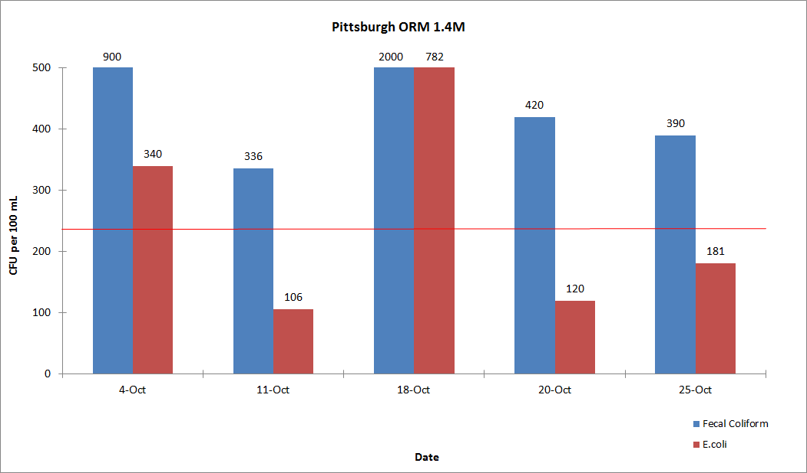

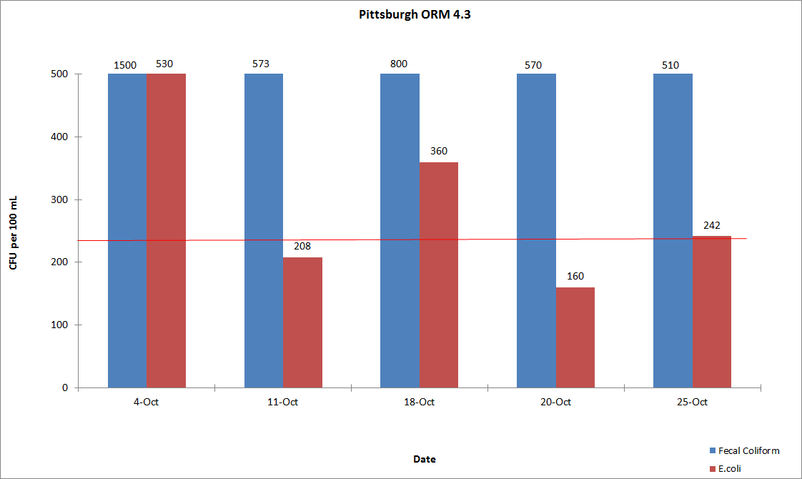

Wheeling
In Wheeling, ORM 86.8 did not exceed the E.coli criteria. ORM 92.8 had one individual exceedance for E.coli.

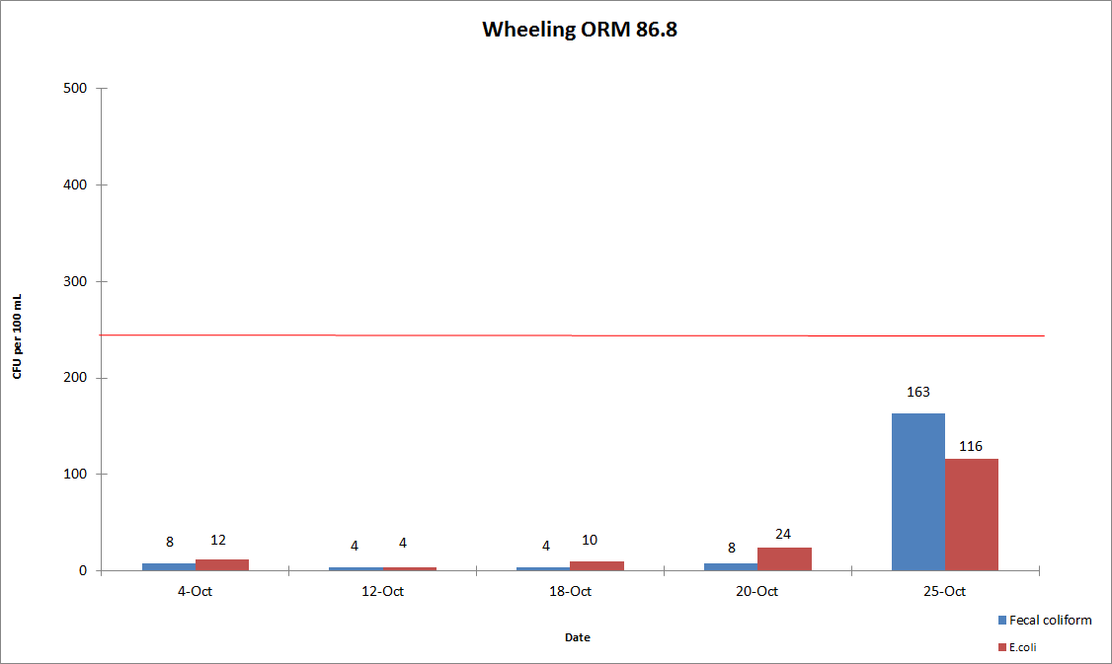

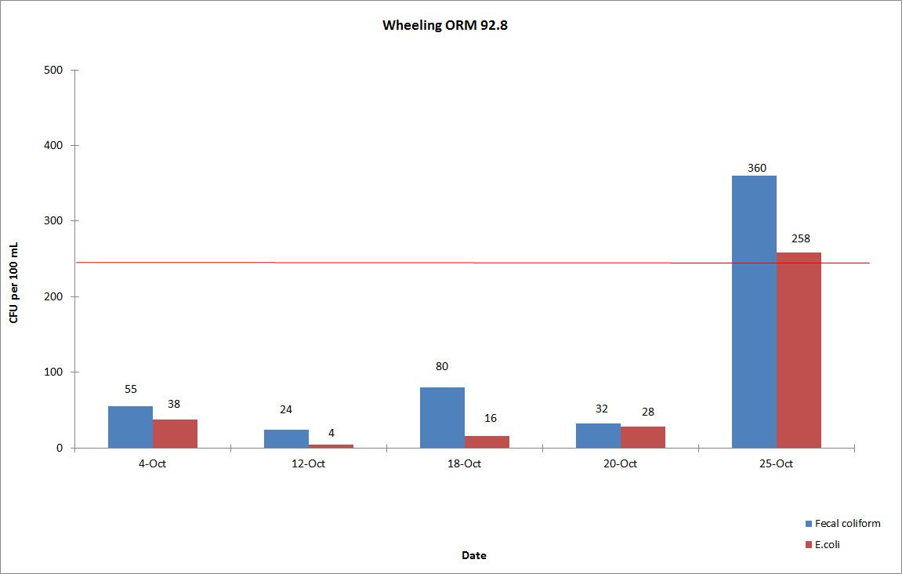

Huntington
In Huntington, ORM 305.1 and ORM 314.8 did not exceed the E.coli criteria.

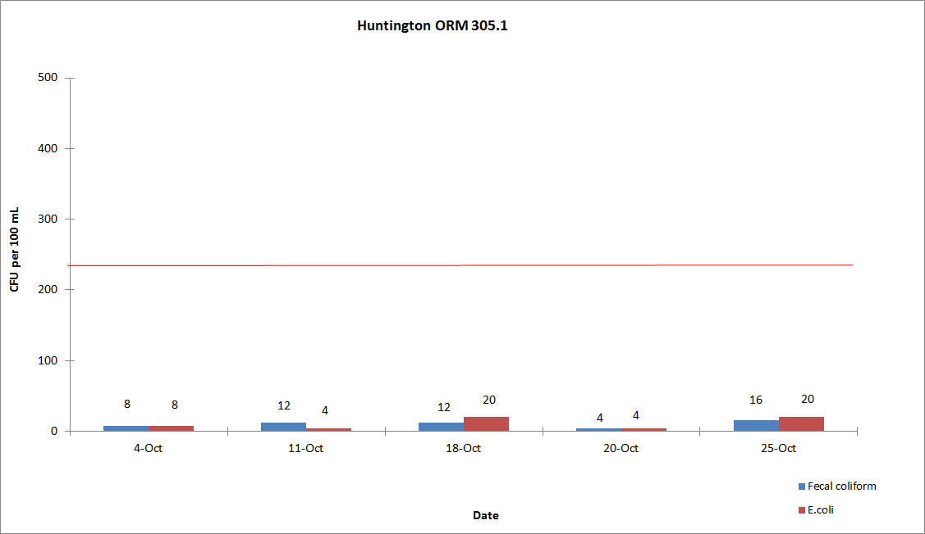

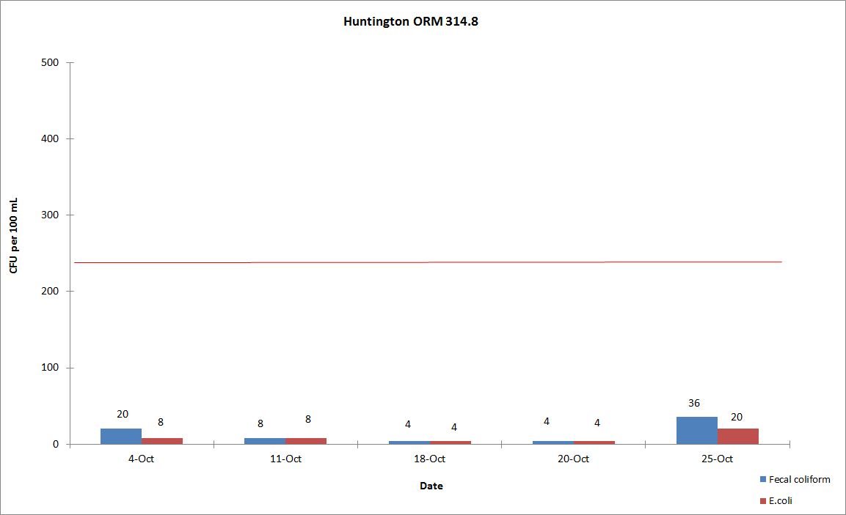
Cincinnati
In Cincinnati, ORM 462.6, ORM 470.0 and ORM 477.5 had one individual exceedance for E.coli.

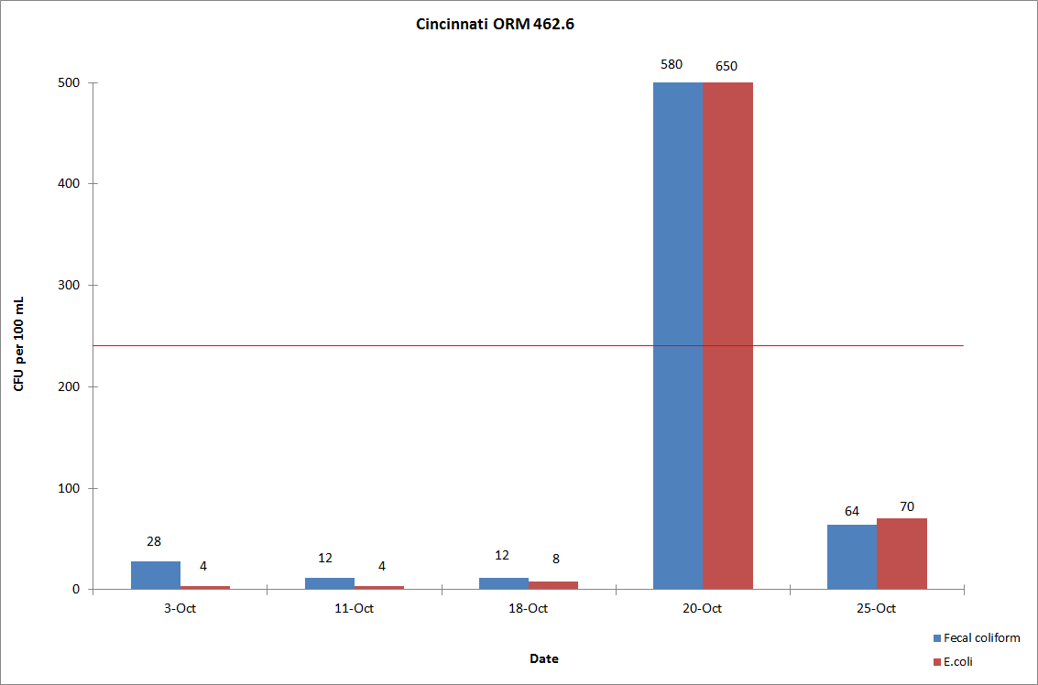

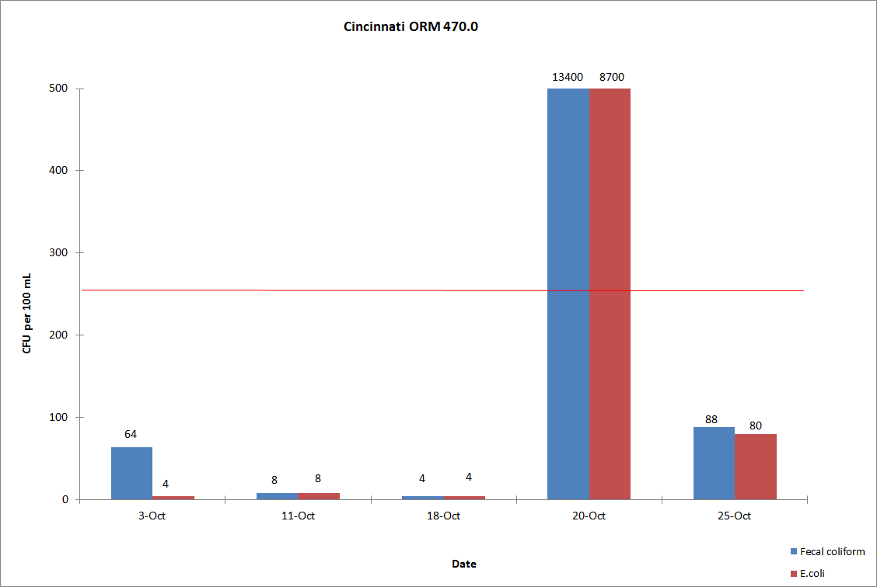
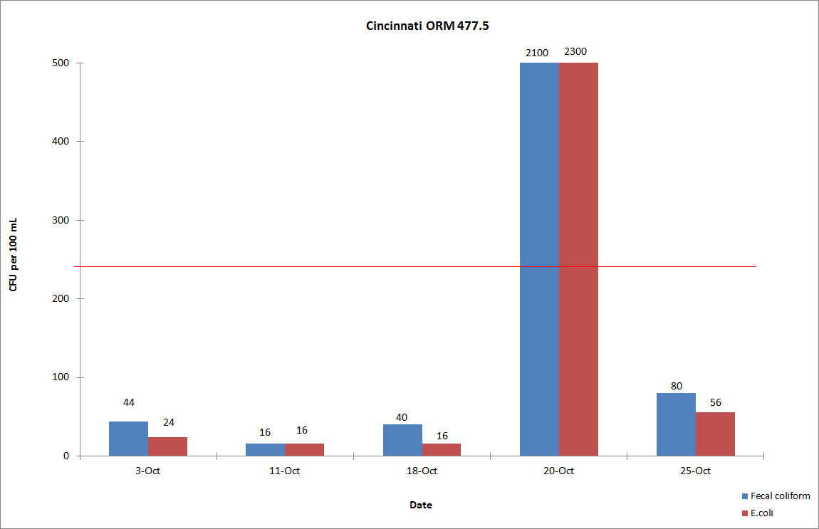

Louisville
In Louisville, ORM 594.0 did not exceed the E.coli criteria. ORM 619.3 had one individual exceedence for E.coli.
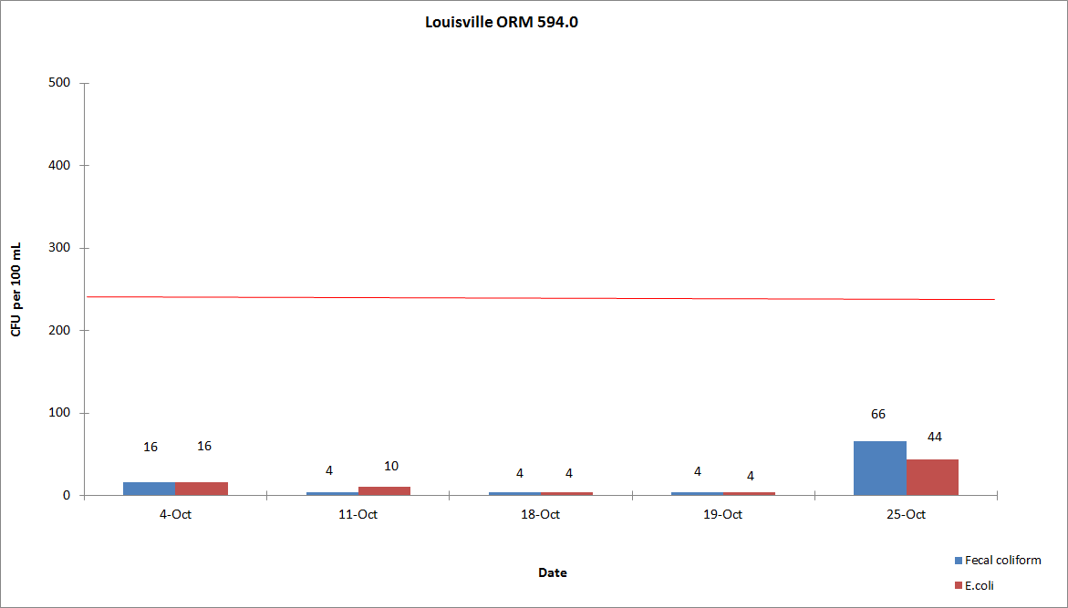
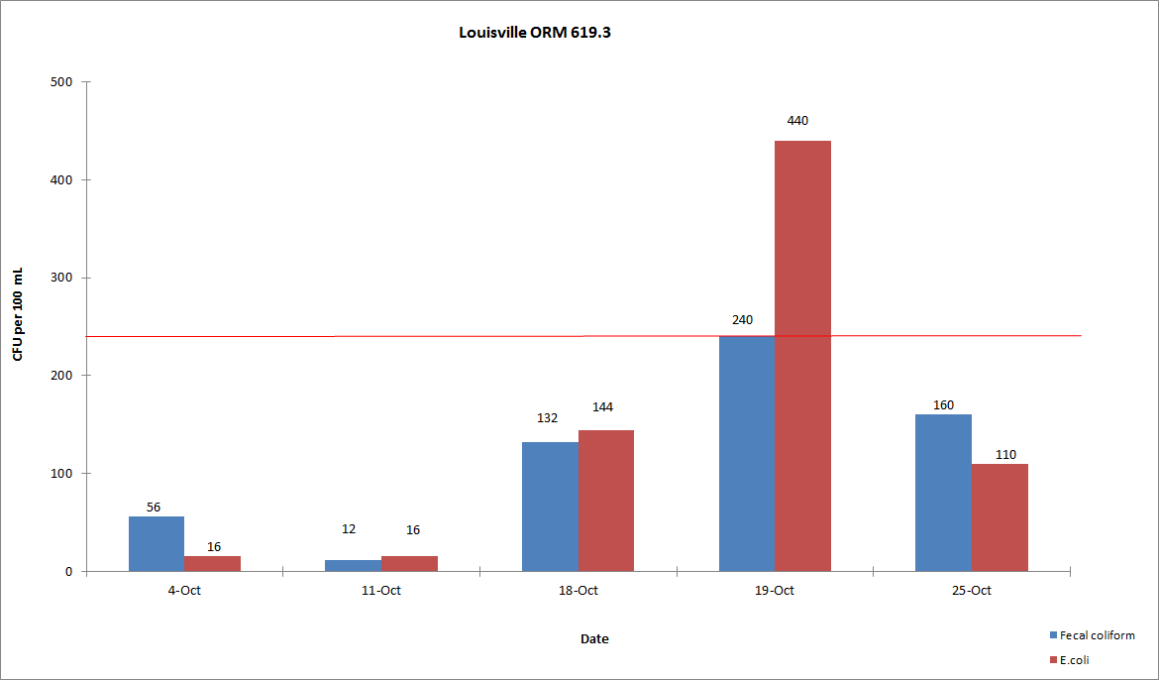

Evansville
In Evansville, ORM 791.5 and ORM 793.7 did not exceed the E.coli criteria.

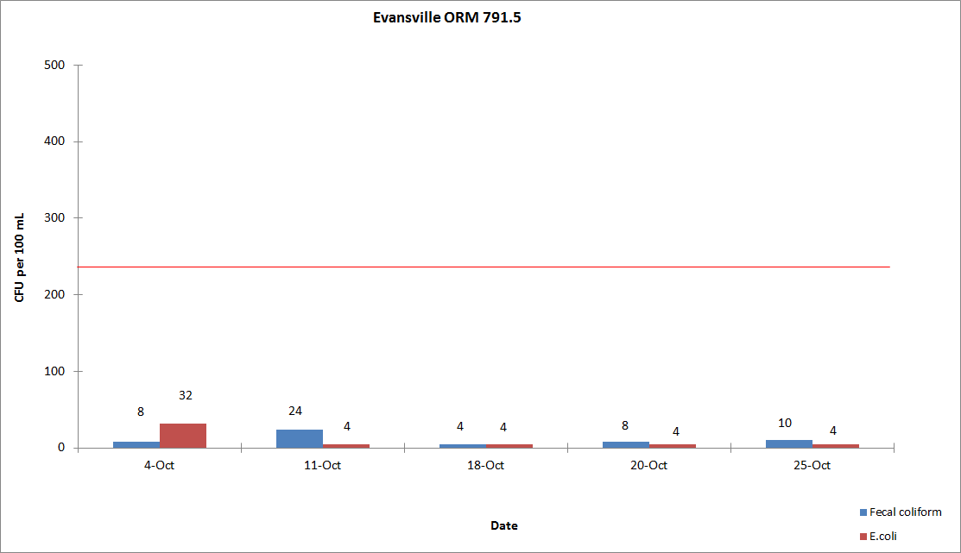

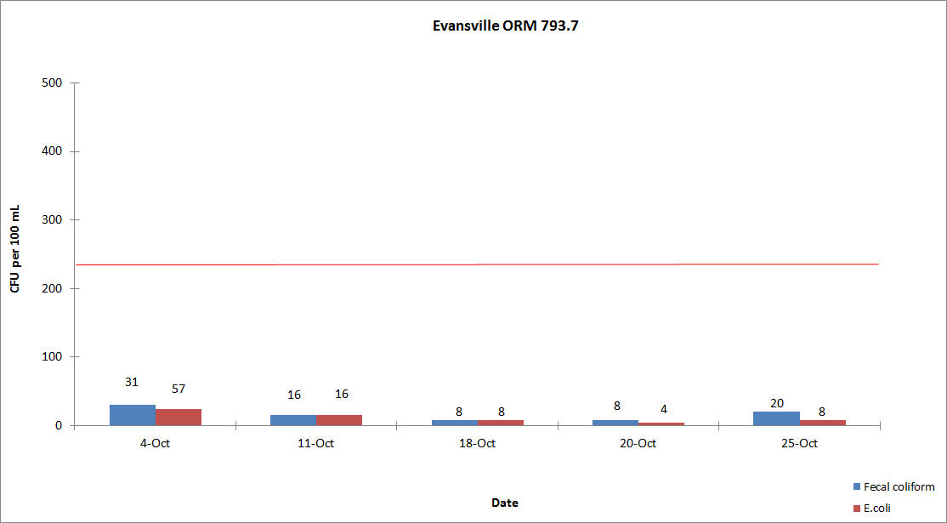

Dissolved Oxygen and Temperature

During the months of May through October, ORSANCO interrogates eight stations for dissolved oxygen (D.O.) and temperature data once per day, Monday through Friday, for the previous 24-hour period. This data is compiled in-house to produce a report showing the minimum, maximum and average of the acquired D.O. and temperature readings. This year Olmstead was added and the results are instantaneous data. ORSANCO’s water quality criteria for the protection of warm water aquatic life habitat are:

- The minimum D.O. concentration shall not be less than 4.0 mg/L at any time.
- Average D.O. concentration shall be at least 5.0 mg/L for each calendar day.
- During the April 15 – June 15 spawning season, a minimum D.O. concentration of 5.0 mg/L shall be maintained at all times.
- The monthly average of the daily maximum for October 1-31 is:

  - 74.1 °F at MP 0 to MP 341.
  - 76.7 °F at MP 341.1 to MP 606.8.
  - 75.5 °F at MP 606.9 to MP 981

There were no D.O. violations for the month of October, but there were multiple days in the beginning of the month that all stations exceeded the Temperature criteria. Kyger and Greenup did have some instrumentation issues when data was unavailable or not valid.

Please click on this link to be directed to the DO/Temperature tables for October 2016: http://www.orsanco.org/dissolved-oxygen-and-temperature

Atrazine

Evansville drinking water utility samples the Ohio River at their intake and analyzes for atrazine by immunoassay technique. Results for October 2016 are presented below. Evansville had no criteria violations of the Maximum Contaminant Level (MCL) of 3.0 ug/L set by the Safe Drinking Water Act for finished drinking water.

