Memo | Ohio River Valley Water  Sanitation Commission  5735 Kellogg Avenue  Cincinnati, Ohio 45230  Telephone: (513) 231-7719  Fax: (513) 231-7761

DATE: October 16, 2013

TO: Technical Committee
Stuart Bruny, Chairman Erich Emery, USACE
Marcia Willhite, IL Thomas Kaminski, USCG
Shivi Selvaratnam, IN Ed Ambrogio, USEPA
Randy Payne, KY William Guertal, USGS
Jeff Konsella, NY Ex Officio¹
Paul Novak/Scott Nally, OH Rob Reash, Chairman, PIAC
Ronald Schwartz, PA Eriks Janelsins, Chairman, PIACO
Melanie Davenport, VA MaryLynn Lodor, Chairman, POTW
Scott Mandirola, WV Ron Bargiel, Chairman, WUAC
Peter Tennant, Chief Engineer
FROM: Stacey Cochran

SUBJECT: Quality Update –September 2013 Conditions

Flows

Average flows at seven Ohio River locations are displayed below. At each location the September 2013 average flow (black bar) is contrasted with the long-term average monthly flow (gray bar). The average flow for September 2013 is above the long-term monthly flow at every location.

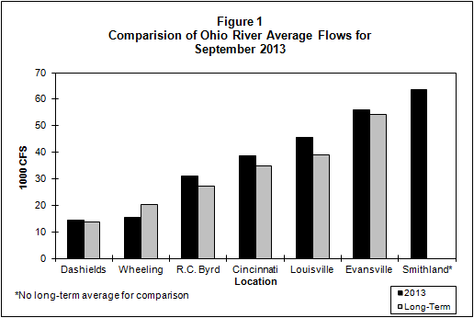

Bacteria

The bacteria monitoring results from six Ohio River locations in September 2013 are in the attached graphs. Beginning with the 2013 Contact Recreation season (April through October), there are thirteen sites being sampled. ORSANCO’s water quality criteria for the protection of human health during the contact recreation season are:

• E. coli count is not to exceed 240 CFU/100mL in more than 25 percent of samples. (E.coli is shown with a red line on the graph.)
• E. coli shall not exceed 130 CFU/100mL as a 90-day geometric mean, based on not less than five samples per month.

ORSANCO’s water quality criteria for the protection of public water supply year round are:

- Fecal Coliform shall not exceed 2,000/100mL as a monthly geometric mean based on not less than five samples per month.

Pittsburgh
In Pittsburgh, ORM 1.4M and ORM 4.3 both had two individual exceedances for E.coli. The 90 day geometric mean could not be calculated due to partial data for July, August and September.

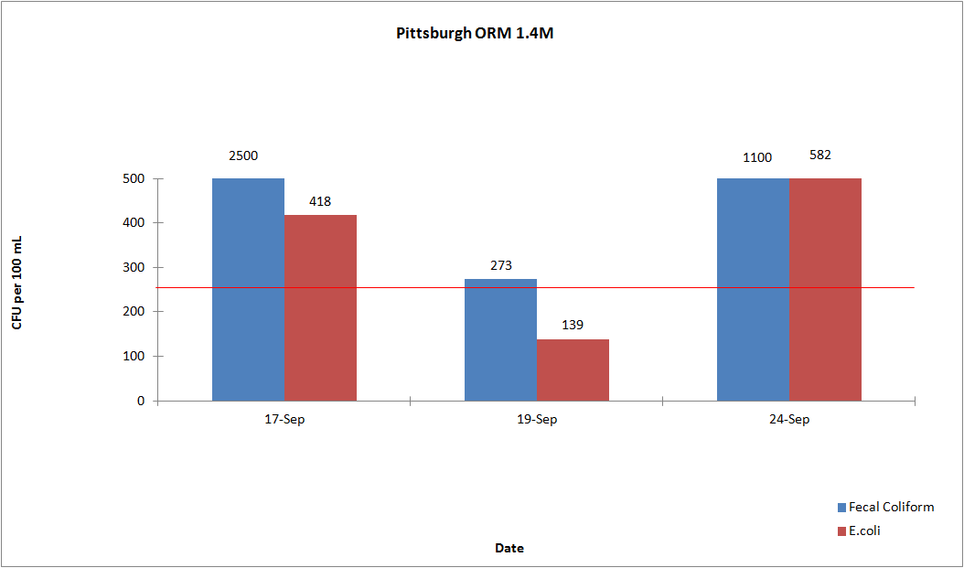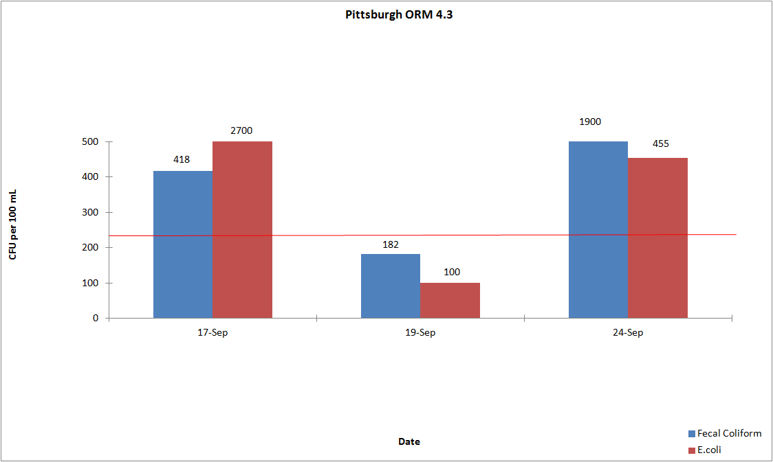

Wheeling
In Wheeling, ORM 86.8 and ORM 92.8 did not exceed the E.coli criteria. The 90 day geometric mean for E.coli was not exceeded at any site.

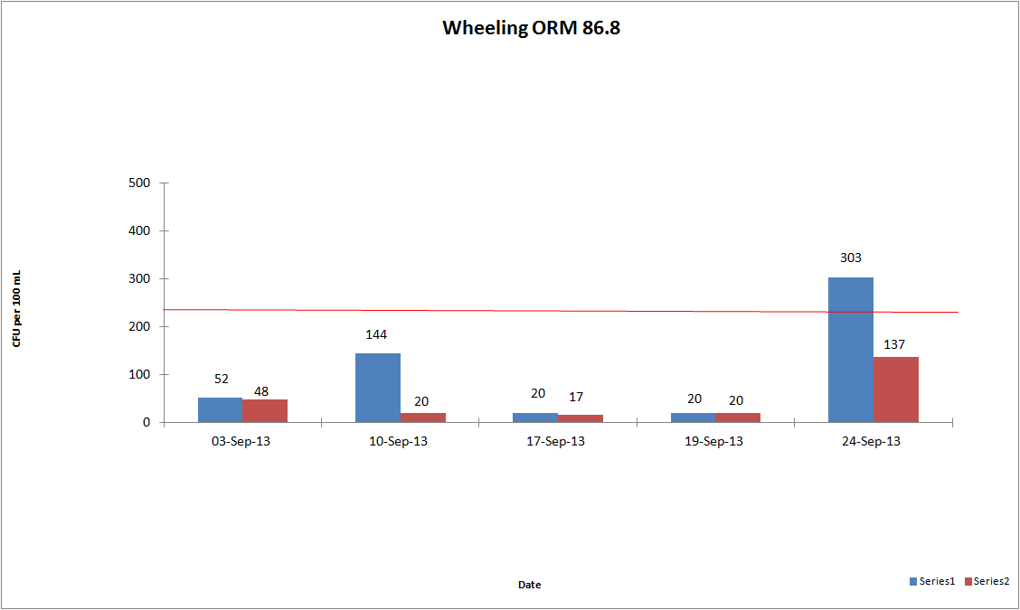
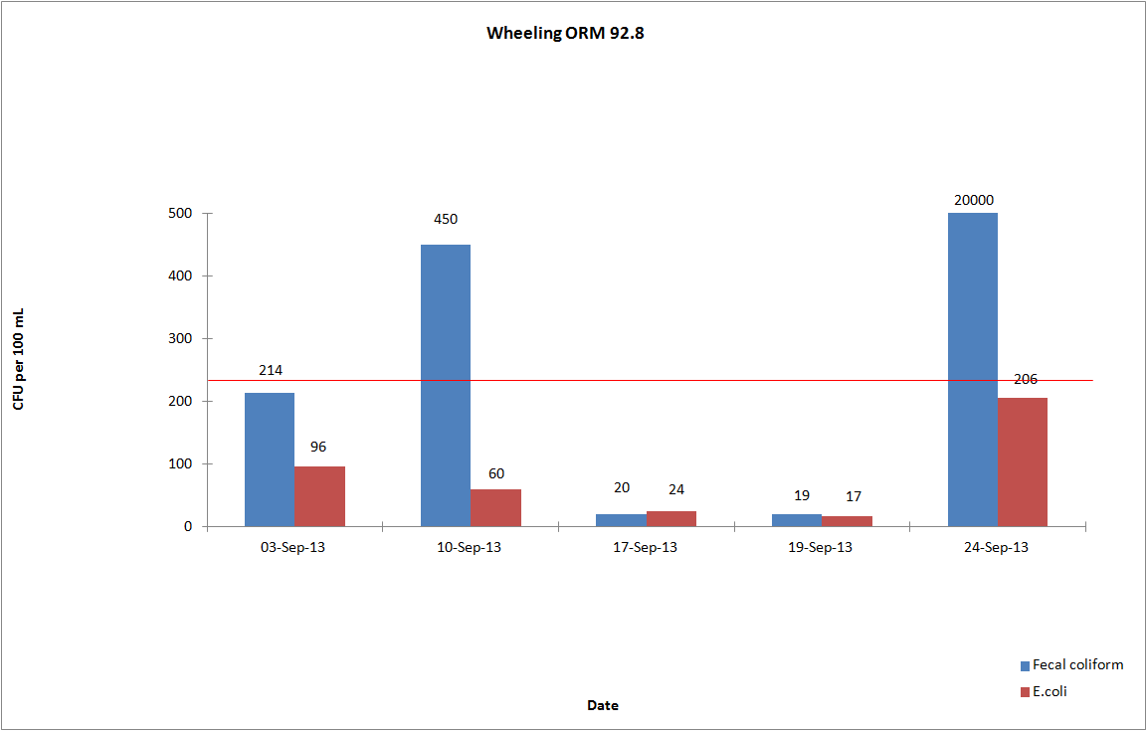

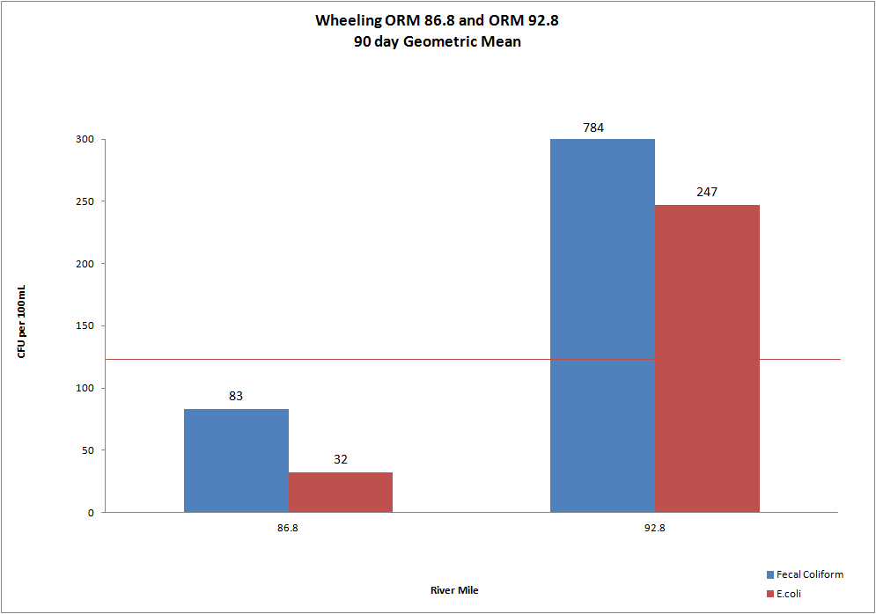

Huntington
In Huntington, ORM 305.1 and ORM 314.8 had no exceedances for E.coli. The 90 day geometric mean for E.coli was not exceeded at either site.

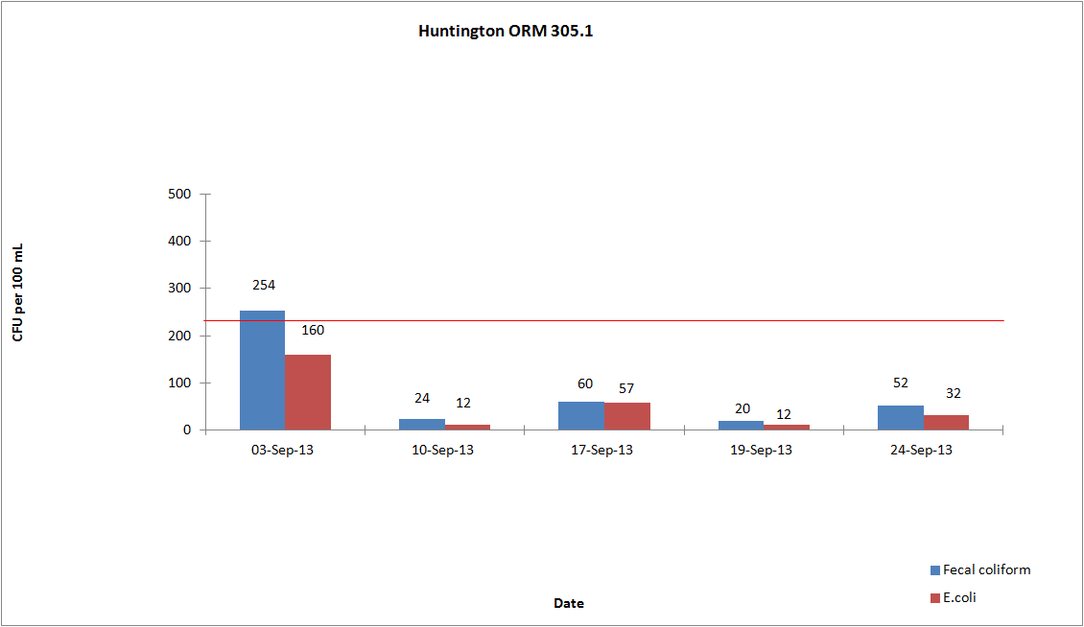

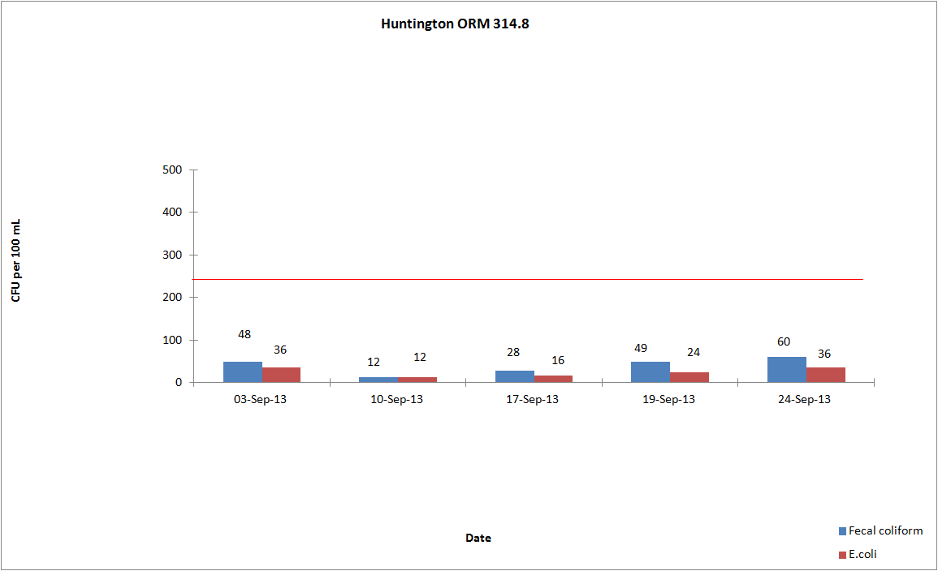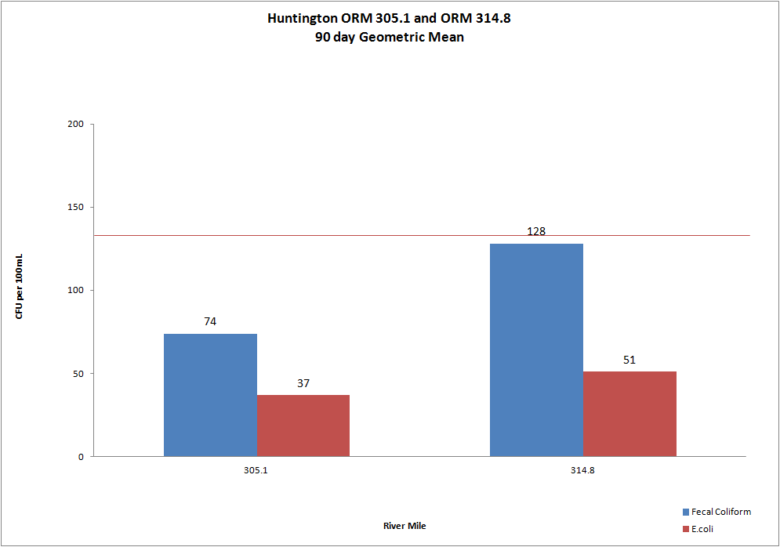

Cincinnati
In Cincinnati, ORM 462.6, ORM 470.0 and ORM 477.5 did not exceed the E.coli criteria. The 90 day geometric mean for E.coli was not exceeded at any site.

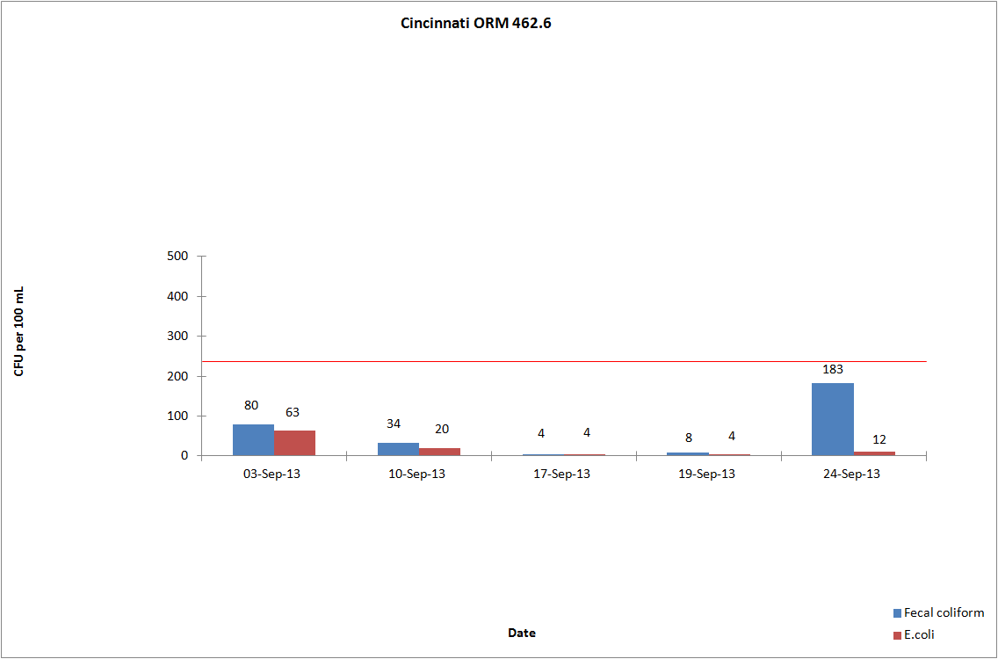
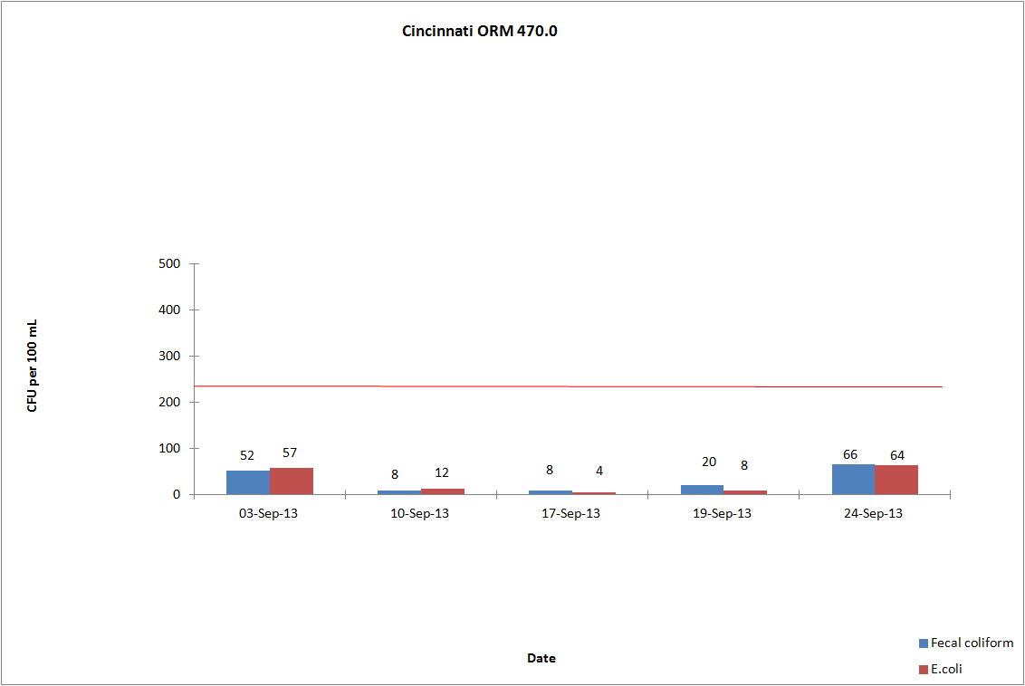

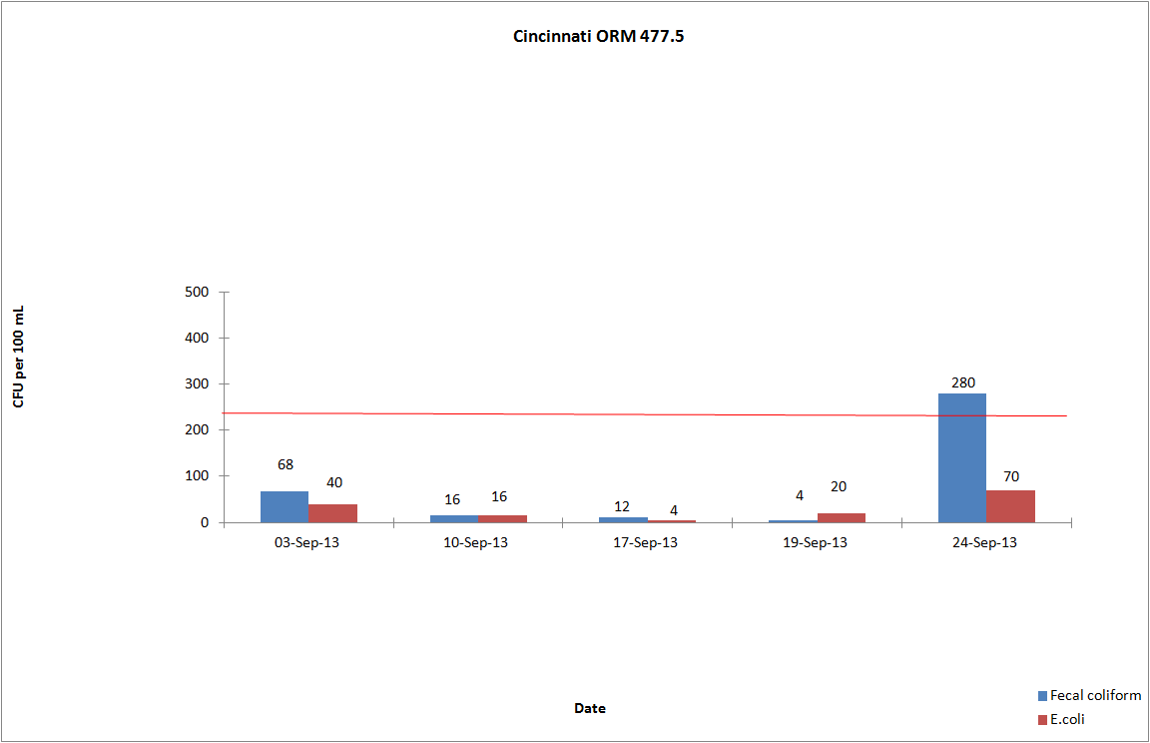
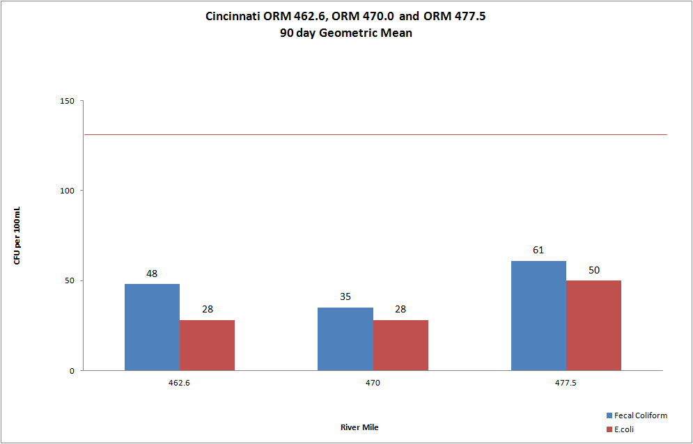

Louisville
In Louisville, ORM 594.0 did not exceed the E.coli criteria. ORM 619.3 had one individual exceedance for E.coli. The 90 day geometric mean for E.coli was not exceeded at either site.

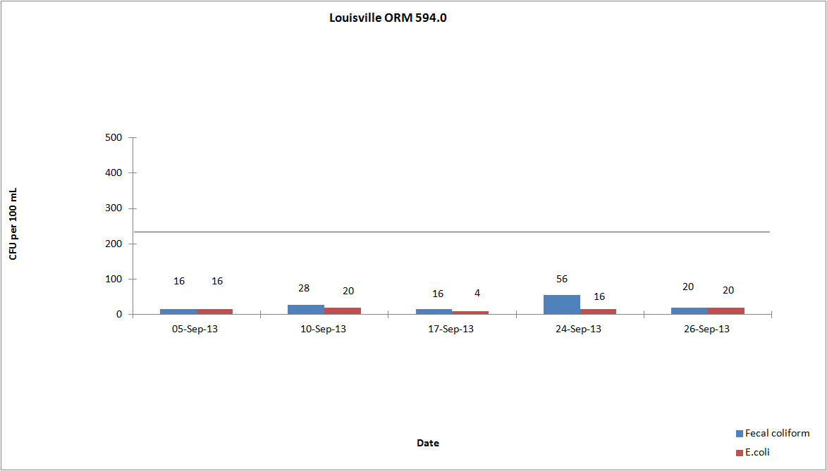

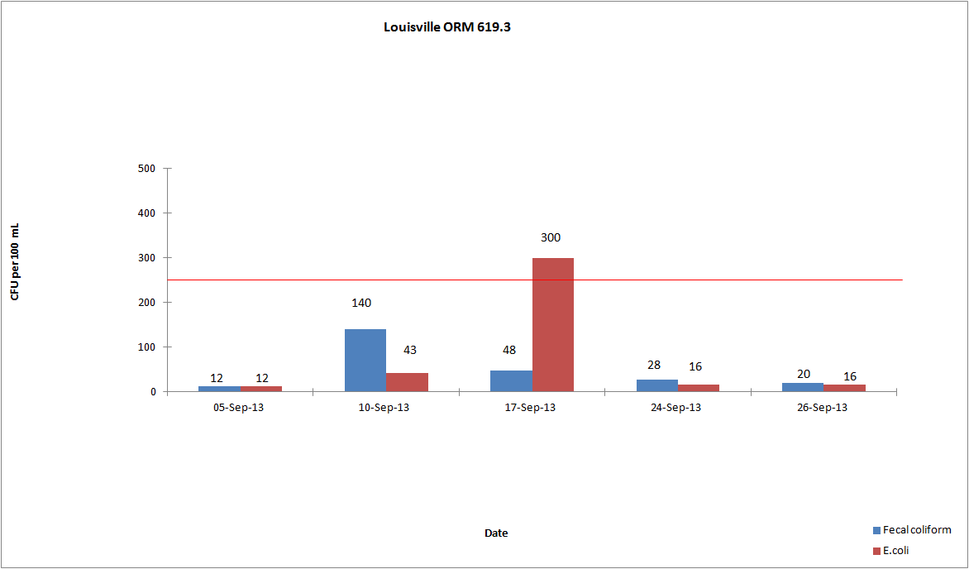

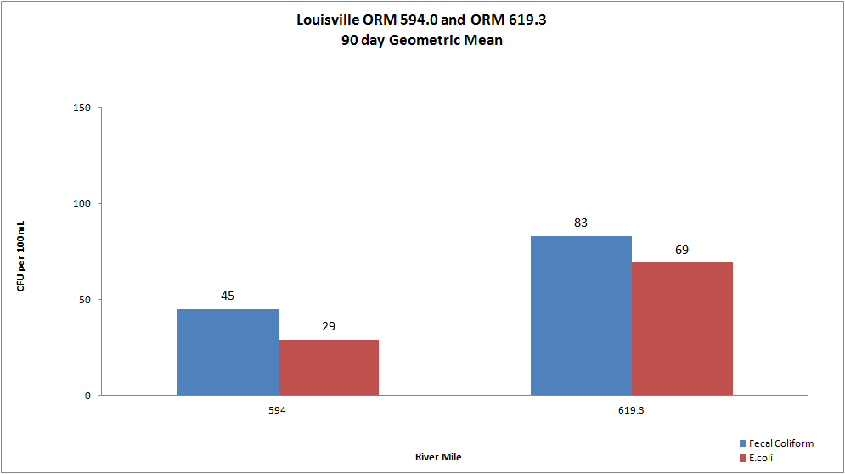

Evansville
In Evansville, ORM 791.5 did not exceed the E.coli criteria. ORM 793.7 has one individual exceedance for E.coli. The 90 day geometric mean for E.coli was not exceeded at either site.

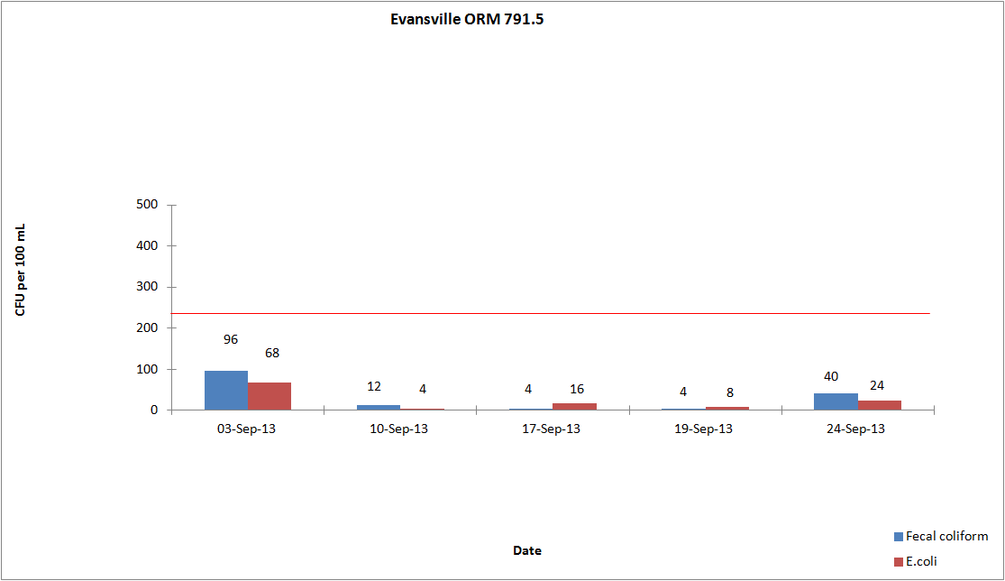

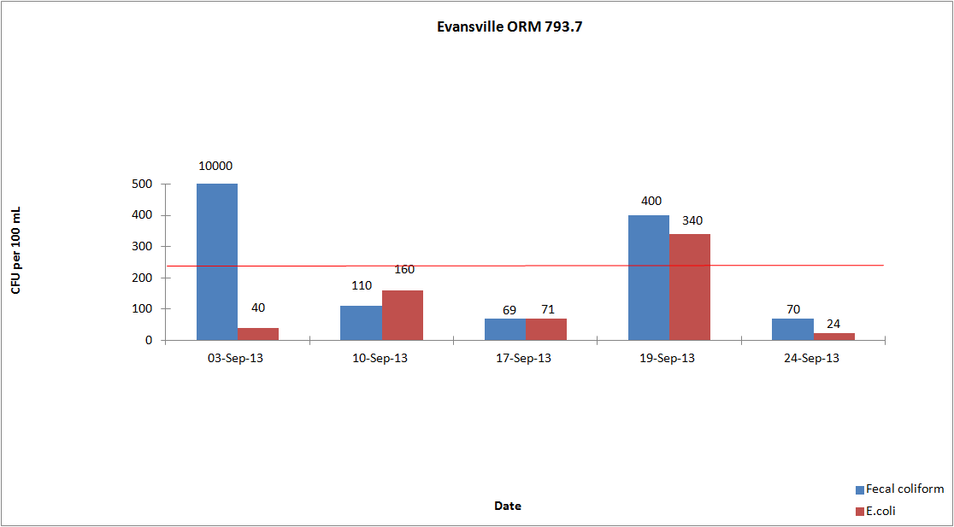

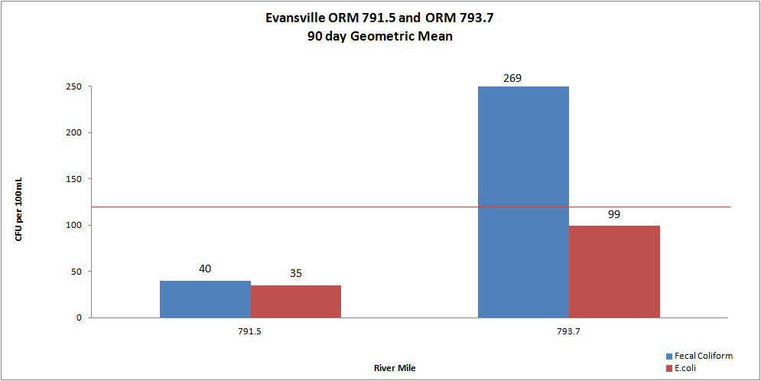

Dissolved Oxygen and Temperature

A summary of the dissolved oxygen and temperature readings collected in September 2013 are displayed in the attached tables. During the months of May through October, ORSANCO interrogates nine stations for dissolved oxygen (D.O.) and temperature data once per day, Monday through Friday, for the previous 24-hour period. This data is compiled in-house to produce a report showing the minimum, maximum and average of the acquired D.O. and temperature readings. ORSANCO’s water quality criteria for the protection of warm water aquatic life habitat are:

- The minimum D.O. concentration shall not be less than 4.0 mg/L at any time.
- Average D.O. concentration shall be at least 5.0 mg/L for each calendar day.
- During the April 15 – June 15 spawning season, a minimum D.O. concentration of 5.0 mg/L shall be maintained at all times.
- The temperature period average for September 1-15 is 84°F and the maximum is 87°F. The temperature period average for September 16-30 is 82°F and the maximum is 86°F.

Kyger Station did have D.O. criteria violations for the month of September. There were no period average temperature violations for the month of September.

Daily D.O. Readings for September 2013
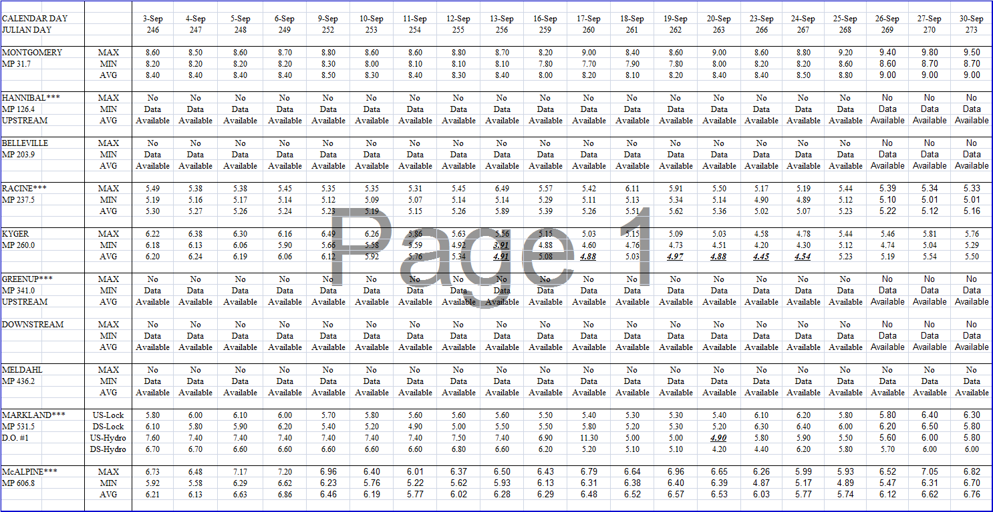

Daily Temperature Readings for September 2013
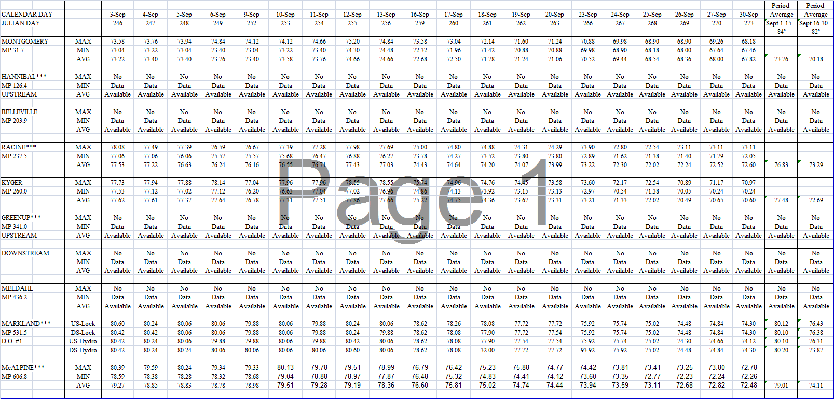
*These tables are also found on our website under the data section.

