Memo | Ohio River Valley Water  Sanitation Commission  5735 Kellogg Avenue  Cincinnati, Ohio 45230  Telephone: (513) 231-7719  Fax: (513) 231-7761

DATE: August 13, 2013

TO: Technical Committee
Stuart Bruny, Chairman Erich Emery, USACE
Marcia Willhite, IL Thomas Kaminski, USCG
Shivi Selvaratnam, IN Ed Ambrogio, USEPA
Randy Payne, KY William Guertal, USGS
Jeff Konsella, NY Ex Officio¹
George Elmaraghy, OH Rob Reash, Chairman, PIAC
Ronald Schwartz, PA Eriks Janelsins, Chairman, PIACO
Melanie Davenport, VA MaryLynn Lodor, Chairman, POTW
Scott Mandirola, WV Ron Bargiel, Chairman, WUAC
Peter Tennant, Chief Engineer
FROM: Stacey Cochran

SUBJECT: Quality Update –July 2013 Conditions

Flows

Average flows at seven Ohio River locations are displayed below. At each location the July 2013 average flow (black bar) is contrasted with the long-term average monthly flow (gray bar). The average flow for July 2013 is above the long-term monthly flow at every location.

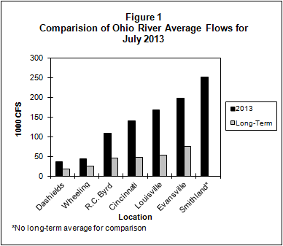

Bacteria

The bacteria monitoring results from six Ohio River locations in July 2013 are in the attached graphs. Beginning with the 2013 Contact Recreation season (April through October), there are thirteen sites being sampled. ORSANCO’s water quality criteria for the protection of human health during the contact recreation season are:

• E. coli count is not to exceed 240 CFU/100mL in more than 25 percent of samples. (E.coli is shown with a red line on the graph.)
• E. coli shall not exceed 130 CFU/100mL as a 90-day geometric mean, based on not less than five samples per month.

ORSANCO’s water quality criteria for the protection of public water supply year round are:

- Fecal Coliform shall not exceed 2,000/100mL as a monthly geometric mean based on not less than five samples per month.

Pittsburgh
In Pittsburgh, ORM 1.4M had two individual exceedances for E.coli. ORM 4.3 had two individual exceedances for E.coli. Due to boat engine issues, ALCOSAN was only able to do two days of sampling. Thus, no 90 day geometric mean is available.

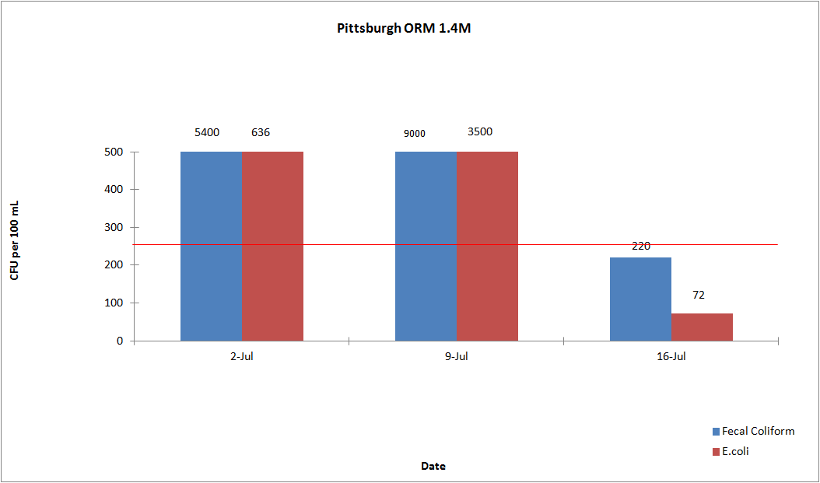

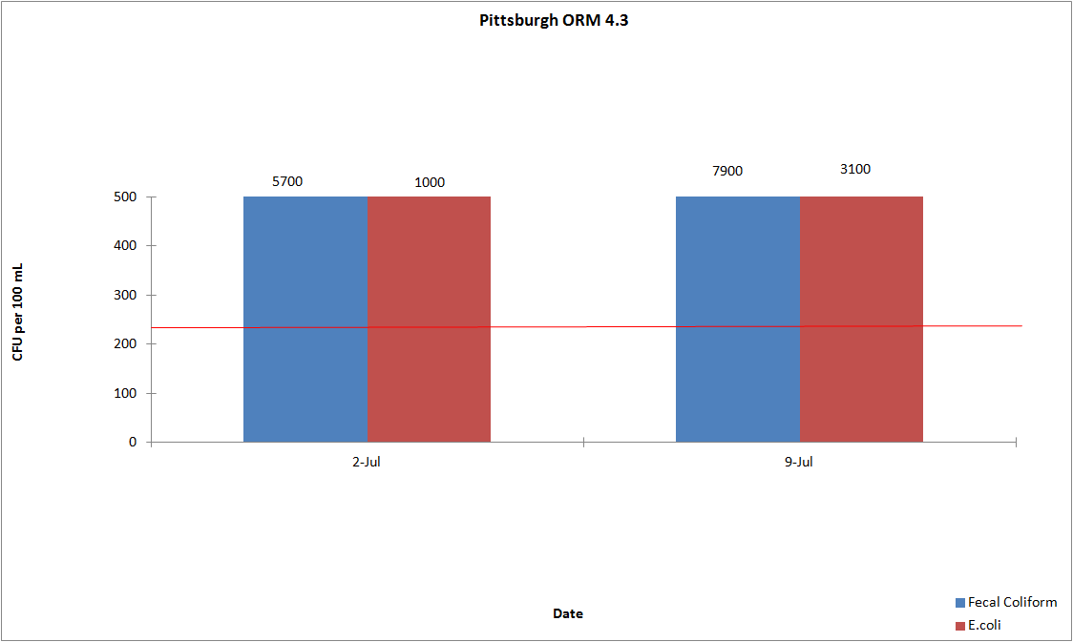

Wheeling
In Wheeling, ORM 86.8 did not exceed the E.coli criteria. ORM 92.8 had four individual exceedances for E.coli. The 90 day geometric mean for E.coli was exceeded at ORM 92.8.

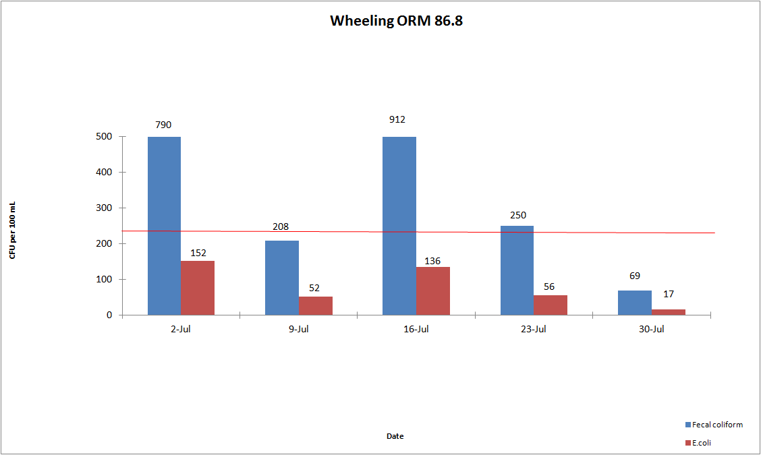

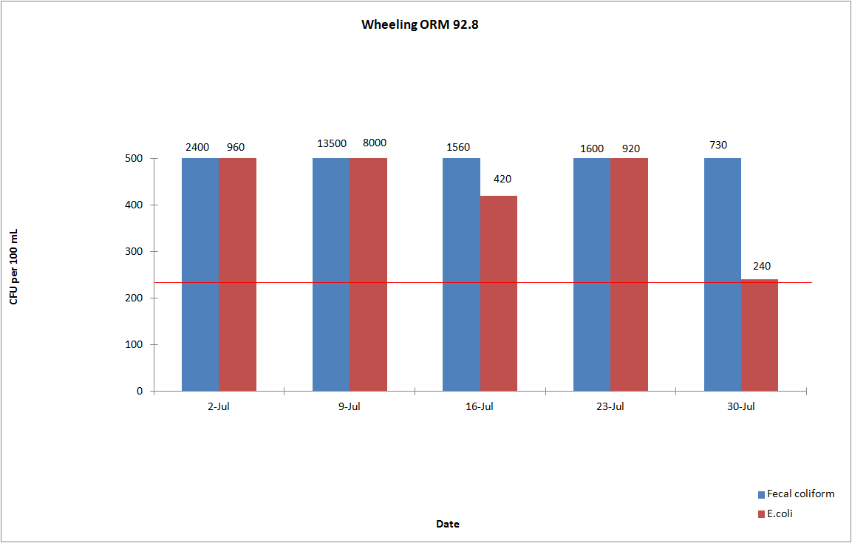

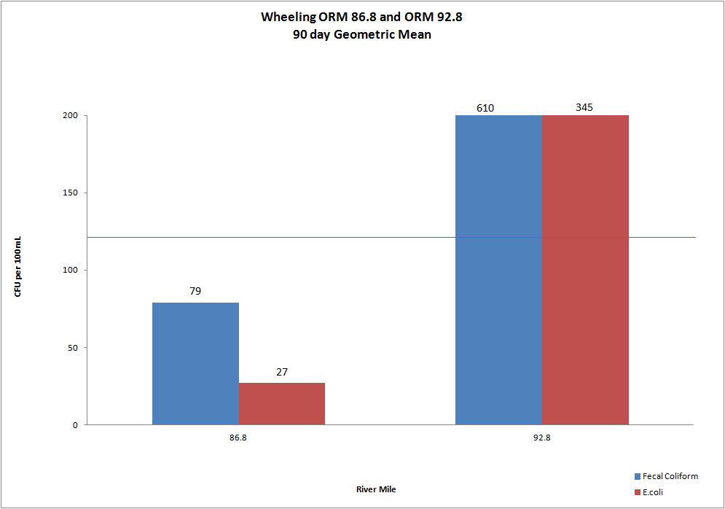

Huntington
In Huntington, ORM 305.1 had one individual exceedance for E.coli. ORM 314.8 had three individual exceedances for E.coli. The 90 day geometric mean for E.coli was not exceeded at either site.
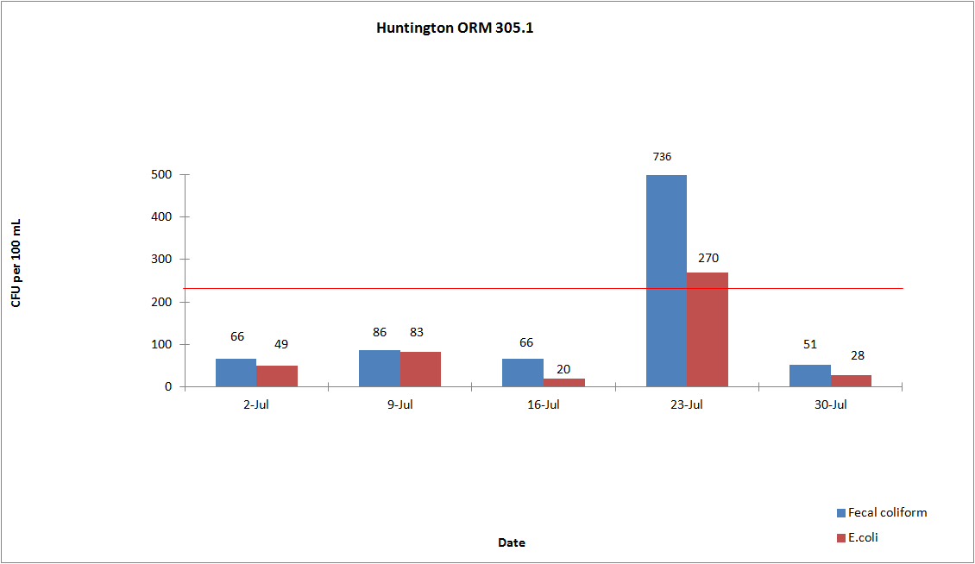

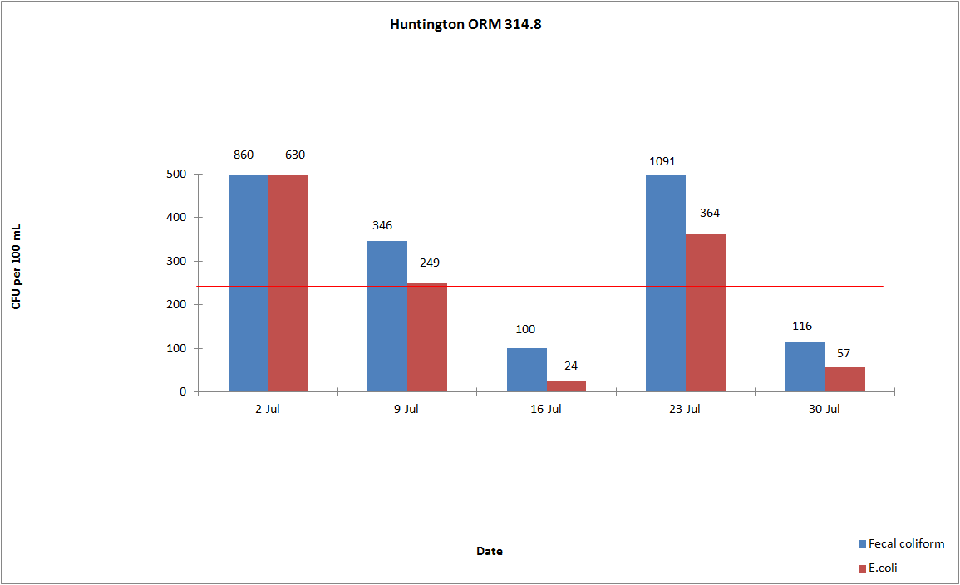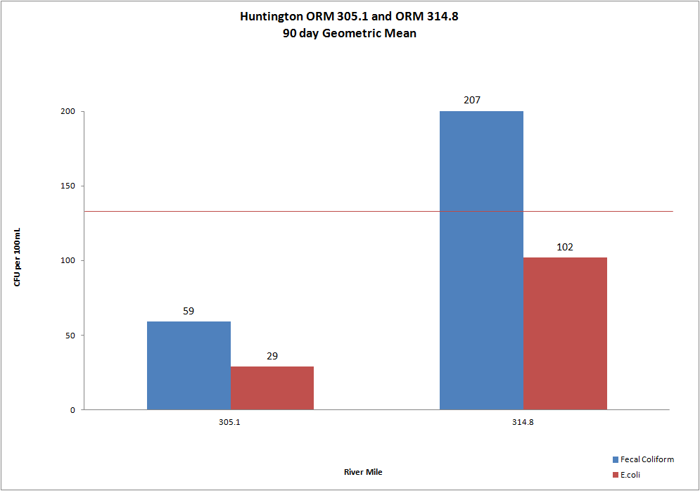

Cincinnati
In Cincinnati, ORM 462.6 did not exceed the E.coli criteria. ORM 470.0 had one individual exceedance for E.coli. ORM 477.5 had three individual exceedances for E.coli. The 90 day geometric mean for E.coli was exceeded at ORM 477.5.
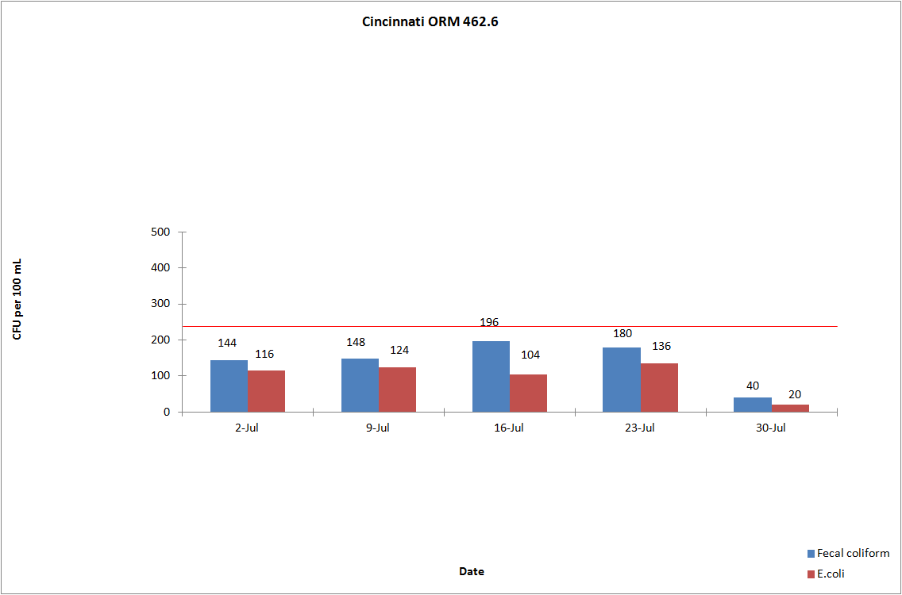

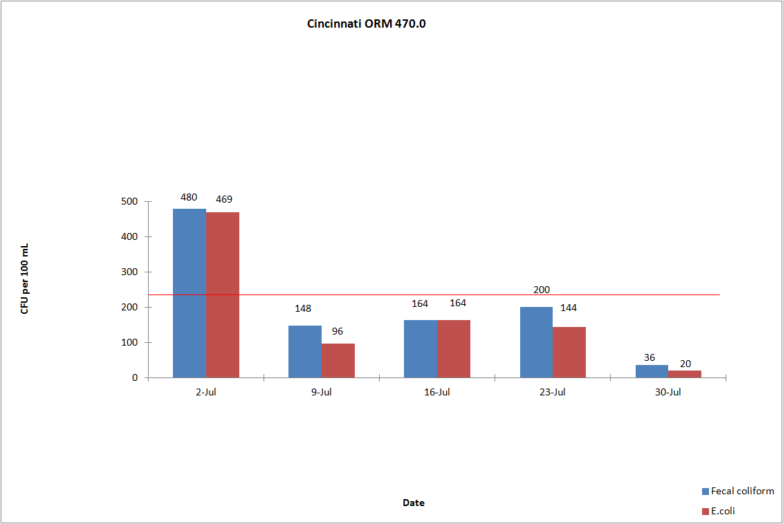

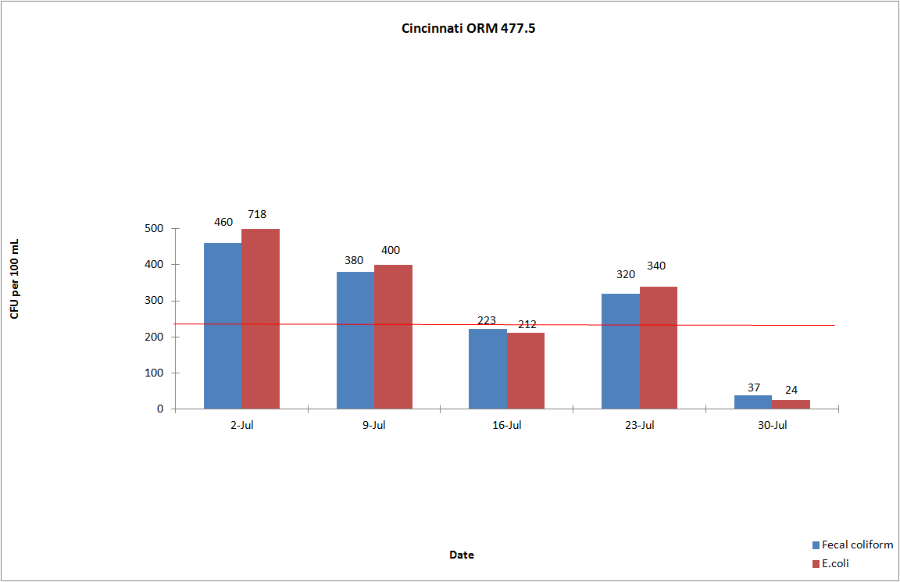

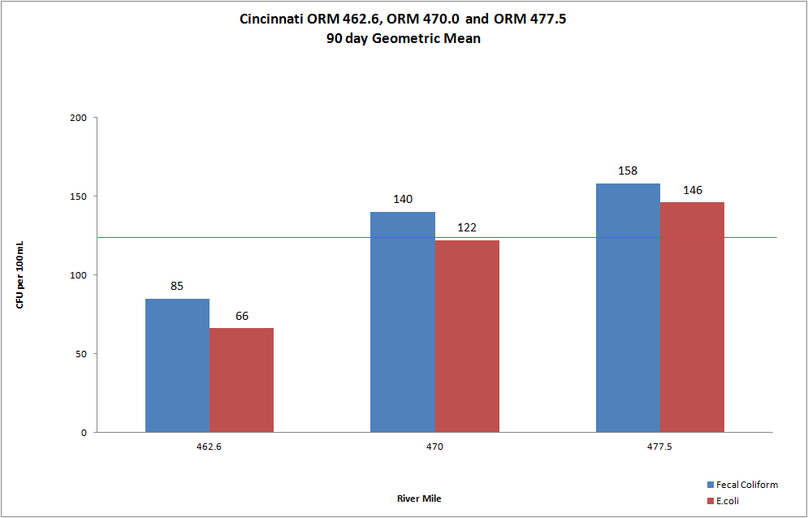

Louisville
In Louisville, ORM 594.0 had one individual exceedance for E.coli. ORM 619.3 had three individual exceedances for E.coli. The 90 day geometric mean for E.coli was not exceeded at either site.
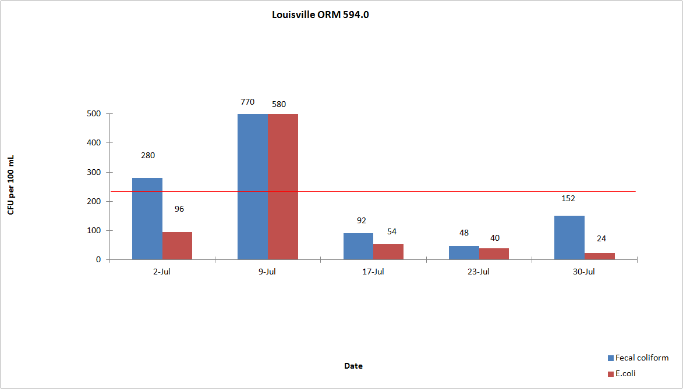

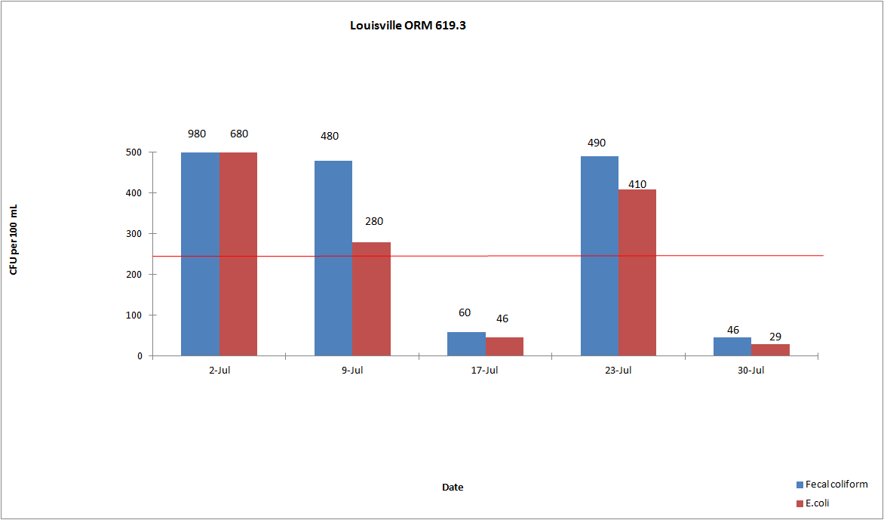

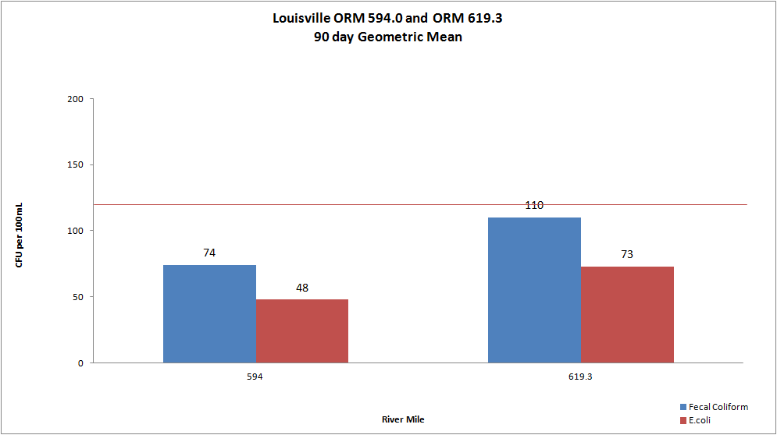

Evansville
In Evansville, ORM 791.5 had one individual exceedance for E.coli. ORM 793.7 had two individual exceedances for E.coli. The 90 day geometric mean for E.coli was exceeded at both sites.

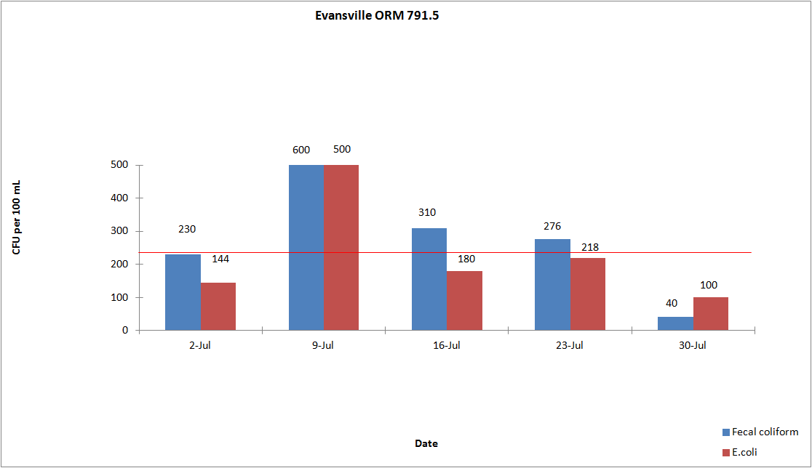

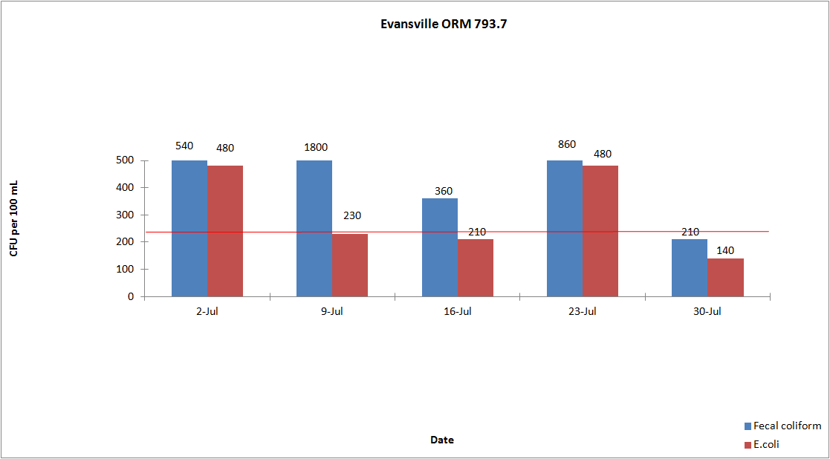

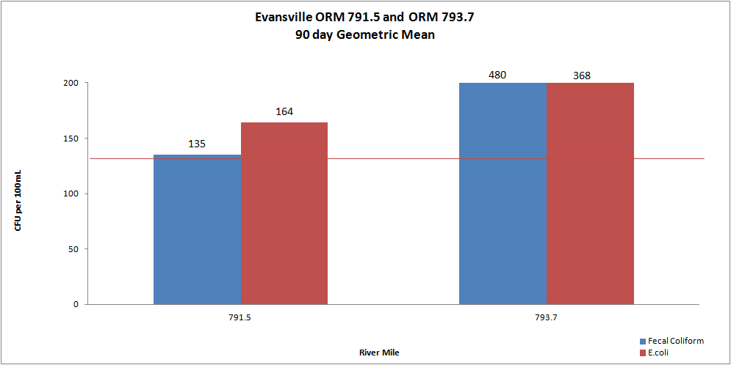

Dissolved Oxygen and Temperature

A summary of the dissolved oxygen and temperature readings collected in July 2013 are displayed in the attached tables. During the months of May through October, ORSANCO interrogates nine stations for dissolved oxygen (D.O.) and temperature data once per day, Monday through Friday, for the previous 24-hour period. This data is compiled in-house to produce a report showing the minimum, maximum and average of the acquired D.O. and temperature readings. ORSANCO’s water quality criteria for the protection of warm water aquatic life habitat are:

- The minimum D.O. concentration shall not be less than 4.0 mg/L at any time.
- Average D.O. concentration shall be at least 5.0 mg/L for each calendar day.
- During the April 15 – June 15 spawning season, a minimum D.O. concentration of 5.0 mg/L shall be maintained at all times.
- The temperature period average for July 1-31 is 84°F and the maximum is 89°F.

Kyger and Markland had a few days in July the D.O. average was below 5.0 mg/L. Hannibal and Greenup had instrument issues and are still being addressed. There were no Temperature violations for the month of July and temperatures were actually well below the period average of 84°F.

Daily D.O. Readings for July 2013

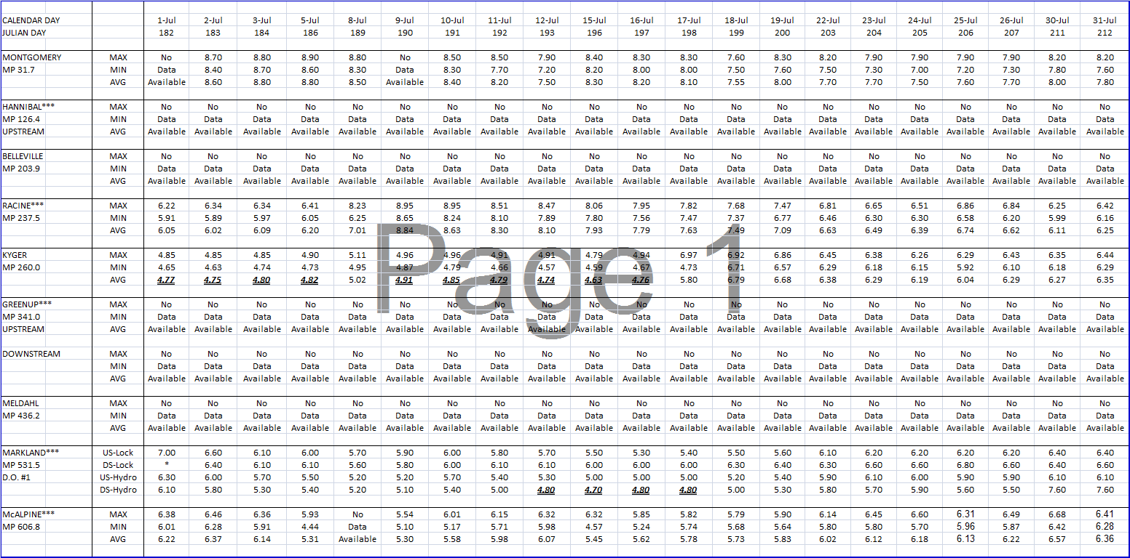

Daily Temperature Readings for July 2013
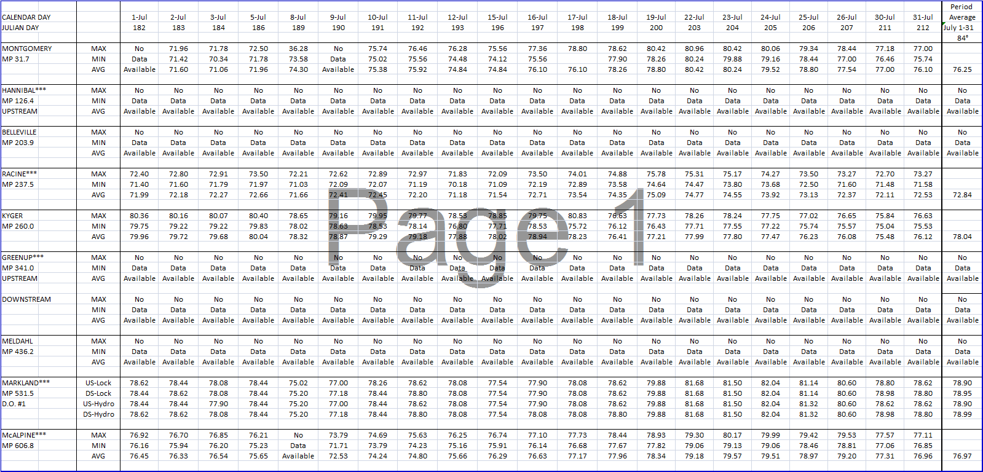

*These tables are also found on our website under the data section.

