Memo | Ohio River Valley Water  Sanitation Commission  5735 Kellogg Avenue  Cincinnati, Ohio 45230  Telephone: (513) 231-7719  Fax: (513) 231-7761

DATE: June 10, 2012

TO: Technical Committee
Toby Frevert, Chairman Allen J. Newman, VA Eriks Janelsins, PIACO
Marcia Willhite , IL Patrick Campbell, WV MaryLynn Lodor, POTW
Thomas Easterly, IN Deborah Lee, USCOE Jack Wang, WUAC
Randy Payne, KY William R. Guertal, USGS Rob Reash, PIAC
Gerard Palumbo, NY John Armstead, U.S. EPA
George Elmaraghy, OH Peter Tennant

Ronald Schwartz, PA

FROM: Stacey Cochran

SUBJECT: Quality Update –May 2012 Conditions

Flows

Average flows at seven Ohio River locations are displayed below. At each location the May 2012 average flow (black bar) is contrasted with the long-term average monthly flow (gray bar). The flows were greater than the long-term average for the month of May.

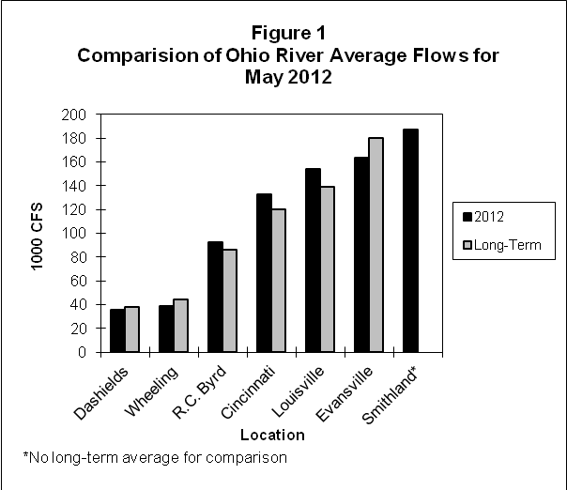

Bacteria

The bacteria monitoring results from six Ohio River locations in May 2012 are in the attached graphs. Beginning with the 2012 Contact Recreation season (May through October), there are thirteen sites being sampled. ORSANCO’s water quality criteria for the protection of human health during the contact recreation season are:

• Fecal coliform count is not to exceed 400 CFU/100mL in more than 10% of the samples taken. (Fecal coliform is shown with a blue line on the graph.)
• Fecal coliform monthly geometric mean of at least five samples is not to exceed 200 CFU/100mL.
• E. coli count is not to exceed 240 CFU/100mL in any single sample. (E.coli is shown with a red line on the graph.)
• E. coli geometric mean of at least five samples is not to exceed 130 CFU/100mL.

All Sites
The site from each location with the highest monthly geometric mean for fecal coliform and E.coli are plotted in the first graph of the attached bacteria monitoring results. There were issues at Pittsburgh and Cincinnati for the month of May resulting in no geometric mean due to lack of data.

Pittsburgh
In Pittsburgh, ORM 1.4M and ORM 4.3 had one individual exceedance for both fecal coliform and E.coli. Due to weather and high water in the Pittsburgh area only two samples were taken for the month of May. Thus there is no monthly geometric mean for fecal coliform or E.coli.

Wheeling
In Wheeling, ORM 86.8 had three individual exceedances for fecal coliform and two individual exceedances for E.coli. ORM 92.8 had two individual exceedances for both fecal coliform and E.coli. The monthly geometric mean for both fecal coliform and E.coli was exceeded at ORM 92.8 and only fecal coliform at ORM 86.8.

Huntington
In Huntington, ORM 305.1 had no exceedances for fecal coliform or E.coli. ORM 314.8 had two individual exceedances for both fecal coliform and E.coli. The monthly geometric mean for both fecal coliform and E.coli was exceeded at ORM 314.8.

Cincinnati
In Cincinnati, ORM 462.6 had two individual exceedances for fecal coliform and one individual exceedance for E.coli. ORM 469.9, ORM 470.0 and ORM 477.5 had two individual exceedances for both fecal coliform and E.coli. ORM 463.9 had one individual exceedance for both fecal coliform and E.coli. The monthly geometric mean for E.coli was exceeded at ORM469.9, ORM 470.0, and ORM 477.5. The lack of fecal coliform data is due to possible cross contamination for fecal coliform on May 10 and the Lab not processing the samples within the 6 hour hold time on May 17.

Louisville
In Louisville, ORM 594.0 and ORM 619.3 had one individual exceedance for both fecal coliform and E.coli. The monthly geometric mean for fecal coliform was exceeded at ORM 619.3. The monthly geometric mean for E.coli was exceeded at ORM 594.0 and ORM 619.3.

Evansville
In Evansville, ORM 791.5 and ORM 793.7 had one individual exceedance for both fecal coliform and E.coli. The monthly geometric mean for E.coli was exceeded at ORM 793.7.

Dissolved Oxygen and Temperature

A summary of the dissolved oxygen and temperature readings collected in May 2012 are displayed in the attached tables. During the months of May through October, ORSANCO interrogates nine stations for dissolved oxygen (D.O.) and temperature data once per day, Monday through Friday, for the previous 24-hour period. This data is compiled in-house to produce a report showing the minimum, maximum and average of the acquired D.O. and temperature readings. ORSANCO’s water quality criteria for the protection of warm water aquatic life habitat are:

- The minimum D.O. concentration shall not be less than 4.0 mg/L at any time.
- Average D.O. concentration shall be at least 5.0 mg/L for each calendar day.
- During the April 15 – June 15 spawning season, a minimum D.O. concentration of 5.0 mg/L shall be maintained at all times.
- The temperature period average for May 1-15 is 68°F and the maximum is 73°F.
- The temperature period average for May 16-31 is 75°F and the maximum is 80°F.

There were no D.O. violations for the month of May. The instrument at Kyger Creek was out for repair and is currently back up and running. Meldahl had an issue with the calibration on the instrument producing invalid data. There were no Temperature violations for the month of May.

